Signed: A. Cox

Date: September 2026

Review: September 2027 or sooner if needed

Personal, Social, Health and Education (PSHE) Policy

Aims and Objectives

At Seaton Delaval First School, PSHE (Personal, Social, Health and Economic Education) is a planned programme of learning where the children acquire the knowledge, understanding and skills they need to keep themselves healthy and safe. PSHE provides the children with the building blocks in order for them to develop healthy, respectful relationships, focusing on family and friendships, in all contexts, including online. This sits alongside the essential understanding of how to be healthy.

As part of our whole school approach, PSHE develops the qualities and attributes that children need to manage opportunities, challenges and responsibilities as they grow up, enabling them to thrive as individuals, family members and members of society. By teaching pupils to stay safe and healthy, and by building self-esteem, resilience and empathy, our effective PSHE programme enables staff to tackle barriers to learning and raise aspirations for our pupils.

Our PSHE curriculum will be taught through discrete PSHE lessons, as well filtering the skills through out many aspects of school life.

Statement of Intent
At Seaton Delaval First School, it is our intent to provide all children with a broad and balanced curriculum that aims to assist children and young people to prepare for adult life by supporting them through their physical, emotional and moral development, and helping them to understand themselves, respect others and form and sustain healthy relationships.

Implementation through Teaching and Learning

The school seeks to provide a safe, secure learning environment for PSHE that enables children and young people to gain accurate knowledge, develop their own values and attitudes, and develop skills to grow into happy confident successful adults. At the beginning of each year, every class sets ground rules that children must follow during PSHE lessons. This creates a safe and supportive learning environment and allows children to feel comfortable and to speak openly and honestly.
At Seaton Delaval First School we promote the needs and interests of all pupils, irrespective of gender, culture or background and all teachers take into account the children’s age, ability and readiness. PSHE will be provided through discreet curriculum time, assemblies, class discussions/circle time, as and when issues arise, ensuring time is made within the curriculum to meet the needs of the children. We respect pupils’ unique starting points by providing learning that is suitable to their level, taking into account their age, maturity and how emotionally secure they are.

Early Years and Foundation Stage

In Early Years, PSED (Personal, Social and Emotional Development) is a prime area of learning therefore an integral aspect of daily planning, teaching and learning.

• Making relationships
• Self-confidence and self-awareness
• Managing feelings and behaviour

Planning is child led to reflect the interests of the children and the needs of the school. Children take part in circle time and discuss topics and themes that are at their level. Teachers look at the three core themes and take aspects of these to inform their planning. PSED is a fundamental building block in a child’s development and underpins the whole curriculum.

Key Stage One and Two

Within Key Stage One and Two PSHE lessons are often more structured and follow the scheme of work that is in place. Each class in these Key Stages will follow The PSHE Association’s ‘PSHE Education Curriculum Model’. The curriculum model is designed to accompany the 2026 edition of the Programme of Study for PSHE education, which covers all of Relationships, Sex and Health education (RSHE), including statutory content for Relationships and Health Education and recommended content for Sex Education, as well as essential learning on Economic Wellbeing and Careers Education.

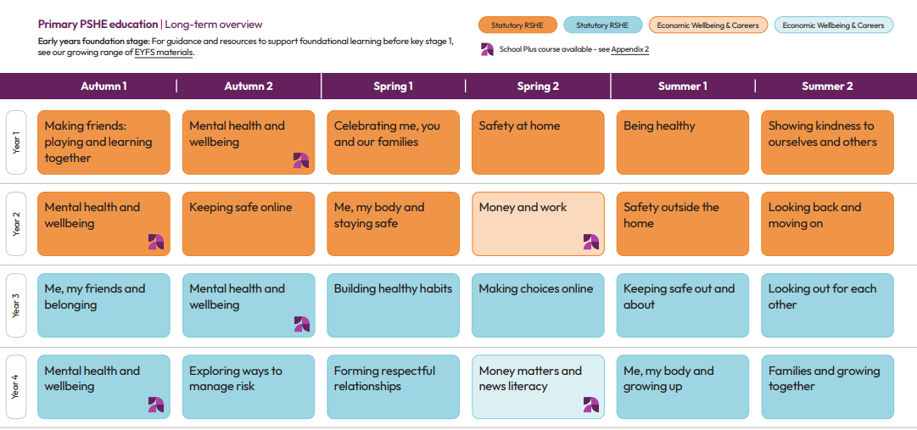
The PSHE Association Key Stage One and Two Long- Term Overview

British Values

As a school we promote British values ensuring that our children leave school prepared for life in modern Britain. We support the values of democracy, rule of law, individual liberty, mutual respect and tolerance of different faiths and beliefs. Through aspects of school life such as voting for school council members, assemblies and discrete PSHE lessons, these values are embedded within our curriculum. We plan assemblies and lessons to teach the children about our values, respecting similarities and differences, tackling stereotypes and understanding why some people discriminate. We aim to empower children to have a voice and to stand up against discrimination, valuing equality, tolerance and mutual respect.

Implementation through Assessment, Recording, Reporting and Monitoring

Teachers assess the children’s work in PSHE by making informal judgements as they observe them during lessons. We have clear expectations of what the pupils will know and understand at the end of each year and key stage. Assessment should offer the children the opportunity to reflect on their own progress. Throughout the school, learning will be visible in a number of ways including book work, photos or records of class discussions. The PSHE subject leader is responsible for monitoring the standards of children’s work and the quality of teaching. The subject leader will monitor plans, teaching and learning in order to evaluate strengths and weaknesses in the school and indicate areas for improvement. The subject leader will regularly evaluate the scheme of work to ensure that the needs of the pupils are being met and that there is progression and continuity of learning through the school.

Implementation through inclusion and variation, including meeting the needs of SEND pupils

As a school, we provide appropriate variation within our primary PSHE curriculum to ensure that all pupils can access, understand and participate in learning. Lessons are adapted to reflect pupils’ different ages, stages of development and individual needs, using age-appropriate language, stories, scenarios, visuals, discussion, role play and practical activities. Teachers provide scaffolding, modelling and additional support where needed, while carefully planned questioning and opportunities for independent thinking allow pupils to develop their understanding at an appropriate level. We also provide opportunities for pupils to share ideas, explore different perspectives and relate learning to their own experiences, ensuring that PSHE is inclusive, engaging and accessible to all.

Implementation through resources

The PSHE Association provide many websites to access a range of resources for this subject. The PSHE curriculum leader will regularly review resources and obtain, within the constraints of the allocated budget, additional resources as necessary.

Implementation through Professional Development and Training

The PSHE subject leader ensures they are kept informed of relevant changes to aspects of PSHE. The subject leader will support colleagues in the teaching of PSHE by giving them information about current developments in the subject and providing a strategic lead and direction for the subject in school.

PSHE - Two Stars (for 2025-2026) and a Wish (for 2026-2027)

*Worth Educating visitor - beneficial to pupils in KS2 (toxic masculinity).

*Cross curricular - embedded in most subjects and everyday school life. Also, focussed on during special days e.g. MacMillan Bake Sale, World Book Day, Fairs etc.

W – Subject leader to attend the SVLP PSHE working group.

Conclusion
This policy should be read in conjunction with the following school policies:
RSHE/ SRE Policy
Drug Policy
Equal Opportunities Policy
Health and Safety Policy
Food Policy
School Travel Plan
Visitors to School Policy
Teaching and Learning Policy
Assessment and Record Keeping Policy
Responding to pupils’ work / Feedback /Marking Policy
ICT/ Computing Policy
Acceptable Use Policies
Online Safety Policy

