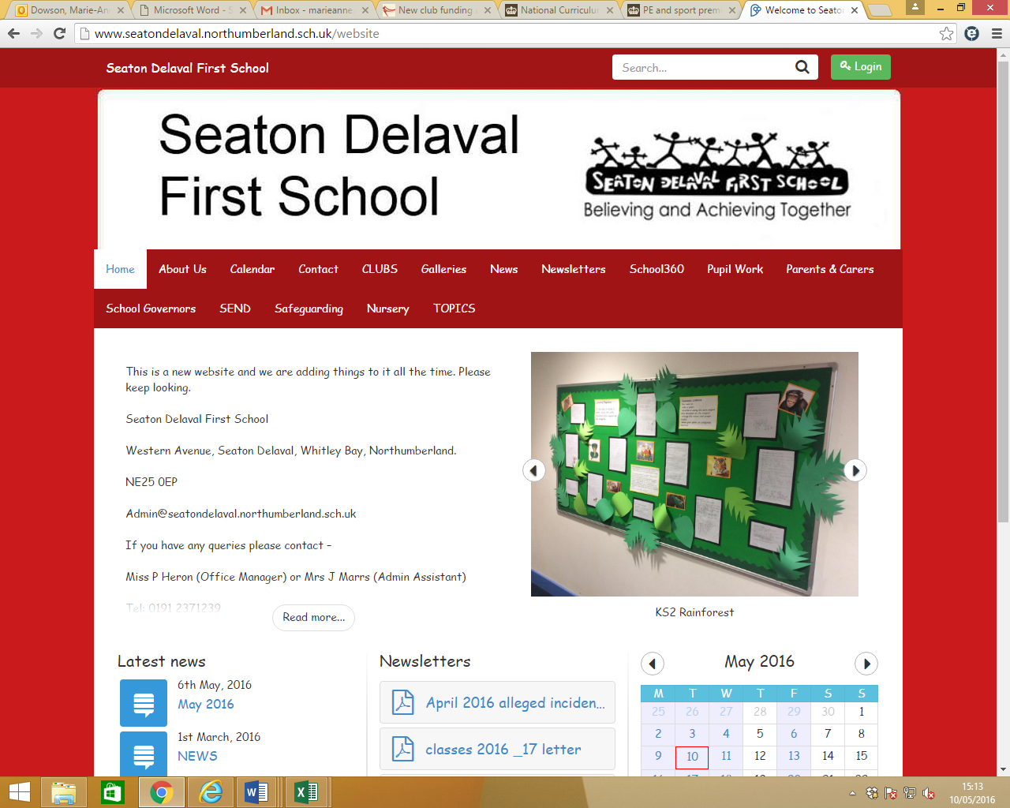

Use of artificial intelligence (AI) policy

Seaton Delaval First School

Date: October 2025

Review: October 2027 or sooner if needed

# Contents

Contents 2

1. Aims and scope 2

2. Legislation 3

3. Regulatory principles 3

4. Roles and responsibilities 4

5. Staff and governors use of AI 6

6. Educating pupils about AI 7

7. Use of AI by pupils 8

8. Formal assessments 8

9. Staff training 8

10. Referral to our child protection and safeguarding policy 9

11. Breach of this policy 9

12. Monitoring and transparency 10

13. Links with other policies 10

Appendix 1: Approved uses of AI tools (table) 12

# 1. Aims and scope

Here at Seaton Delaval First School we understand the valuable potential that artificial intelligence (AI), including generative AI, holds for schools. For example, it can be used to enhance pedagogical methods, customise learning experiences and progress educational innovation.

We are also aware of the risks posed by AI, including data protection breaches, copyright issues, ethical complications, safeguarding and compliance with wider legal obligations.

Therefore, the aim of this policy is to establish guidelines for the ethical, secure and responsible use of AI technologies across our whole school community.

This policy covers the use of AI tools by school staff, governors and pupils. This includes generative chatbots such as ChatGPT and Google Gemini (please note, this list is not exhaustive).

This policy aims to:

* Support the use of AI to enhance teaching and learning
* Support staff to explore AI solutions to improve efficiency and reduce workload
* Prepare staff, governors and pupils for a future in which AI technology will be an integral part
* Promote equity in education by using AI to address learning gaps and provide personalised support
* Ensure that AI technologies are used ethically and responsibly by all staff, governors and pupils
* Protect the privacy and personal data of staff, governors and pupils in compliance with the UK GDPR
  1. Definitions

This policy refers to both ‘open’ and ‘closed’ generative AI tools. These are defined as follows:

* **Open generative AI tools** are accessible and modifiable by anyone. They may store, share or learn from the information entered into them, including personal or sensitive information
* **Closed generative AI tools** are generally more secure, as external parties cannot access the data you input

# 2. Legislation

This policy reflects good practice guidelines/recommendations in the following publications:

* [AI regulation white paper](https://www.gov.uk/government/publications/ai-regulation-a-pro-innovation-approach/white-paper), published by the Department for Science, Innovation and Technology, and the Office for Artificial Intelligence
* [Generative artificial intelligence (AI) and data protection in schools](https://www.gov.uk/guidance/data-protection-in-schools/generative-artificial-intelligence-ai-and-data-protection-in-schools), published by the Department for Education (DfE)

This policy also meets the requirements of the:

* UK General Data Protection Regulation (UK GDPR) – the EU GDPR was incorporated into UK legislation, with some amendments, by [The Data Protection, Privacy and Electronic Communications (Amendments etc) (EU Exit) Regulations 2020](https://www.legislation.gov.uk/uksi/2020/1586/made)
* [Data Protection Act 2018 (DPA 2018)](http://www.legislation.gov.uk/ukpga/2018/12/contents/enacted)

# 3. Regulatory principles

We follow the 5 principles set out in the [AI regulation white paper](https://www.gov.uk/government/publications/ai-regulation-a-pro-innovation-approach/white-paper).

| Regulatory principle | WE WILL … |
| --- | --- |
| Safety, security and robustness | * Ensure that AI solutions are secure and safe for users and protect users’ data * Ensure we can identify and rectify bias or error * Anticipate threats such as hacking |
| Appropriate transparency and explainability | * Be transparent about our use of AI, and make sure we understand the suggestions it makes |
| Fairness | * Only use AI solutions that are ethically appropriate, equitable and free from prejudice – in particular, we will fully consider any bias relating to small groups and protected characteristics before using AI, monitor bias closely and correct problems where appropriate |
| Accountability and governance | * Ensure that the governing board and staff have clear roles and responsibilities in relation to the monitoring, evaluation, maintenance and use of AI |
| Contestability and redress | * Make sure that staff are empowered to correct and overrule AI suggestions – decisions should be made by the user of AI, not the technology * Allow and respond appropriately to concerns and complaints where AI may have caused error resulting in adverse consequences or unfair treatment |

# 4. Roles and responsibilities

4.0 AI lead

Our generative AI lead is Mrs Edwards. They are responsible for the day-to-day leadership, ownership and management of AI use in the school.

4.1 Governing board

The governing board will:

* Take overall responsibility for monitoring this policy and holding the headteacher to account for its implementation in line with the school’s AI strategy
* Ensure the headteacher and AI lead are appropriately supported to make informed decisions regarding the effective and ethical use of AI in the school
* Adhere to the guidelines below to protect data when using generative AI tools:
* Use only approved AI tools (see section 5 and appendix 1)
* Seek advice from the data protection officer, IT, AI lead and the designated safeguarding lead, as appropriate
* Check whether they are using an open or closed generative AI tool
* Ensure there is no identifiable information included in what they put into open generative AI tools
* Acknowledge or reference the use of generative AI in their work
* Fact-check results to make sure the information is accurate

4.2 Headteacher

The headteacher will:

* Liaise with the data protection officer (DPO) to ensure that the use of AI is in accordance with data protection legislation
* Liaise with the DSL to ensure that the use of AI is in accordance with Keeping Children Safe in Education and the school’s child protection and safeguarding policy
* Ensure that the guidance set out in this policy is followed by all staff
* Review and update this AI policy as appropriate, and at least every second year or sooner if needed
* Ensure staff are appropriately trained in the effective use and potential risks of AI
* Make sure pupils are taught about the effective use and potential risks of AI
* Sign off on approved uses of AI, or new AI tools, taking into account advice from the DPO, AI lead, and data protection impact assessments

4.3 Data protection officer (DPO)

The data protection officer (DPO) is responsible for monitoring and advising on our compliance with data protection law, including in relation to the use of AI.

Our DPO is Mr O Flitcroft and is contactable via 0191 237 1239.

4.4 Designated safeguarding lead (DSL)

The DSL is responsible for monitoring and advising on our compliance with safeguarding requirements including in relation to the use of AI, such as:

* Being aware of new and emerging safeguarding threats posed by AI
* Updating and delivering staff training on AI safeguarding threats
* Responding to safeguarding incidents in line with Keeping Children Safe in Education (KCSIE) and the school’s child protection and safeguarding policy
* Understanding the filtering and monitoring systems and processes in place on school devices

The school’s DSL are Mrs A Brown and Mr O Flitcroft and is contactable via 0191 237 1239.

4.5 All staff

As part of our aim to reduce staff workload while improving outcomes for our pupils, we encourage staff to explore opportunities to meet these objectives through the use of approved AI tools. Any use of AI must follow the guidelines set out in this policy.

To protect data when using generative AI tools, staff must:

* Use only approved AI tools (see section 5 and appendix 1)
* Seek advice from the data protection officer , IT , AI lead, as appropriate
* Report safeguarding concerns to the DSL in line with our school’s child protection and safeguarding policy
* Check whether they are using an open or closed generative AI tool
* Ensure there is no identifiable information included in what they put into open generative AI tools
* Acknowledge or reference the use of generative AI in their work
* Fact-check results to make sure the information is accurate

All staff play a role in ensuring that pupils understand the potential benefits and risks of using AI in their learning. All of our staff have a responsibility to guide pupils in critically evaluating AI-generated information and understanding its limitations.

4.6 Pupils

Pupils must:

* Follow the guidelines set out in section 7 of this policy (‘Use of AI by pupils’)

# 5. Staff and governors’ use of AI

5.1 Approved use of AI

We are committed to helping staff and governors reduce their workload. Generative AI tools can make certain written tasks quicker and easier to complete, but cannot replace the judgement and knowledge of a human expert.

Whatever tools or resources are used to produce plans, policies or documents, the quality and content of the final document remains the professional responsibility of the person who produced it.

Any plans, policies or documents created using AI should be clearly attributed. Any member of staff or governor using an AI-generated plan, policy or document should only share the AI-generated content with other members of staff or governors for use if they are confident of the accuracy of the information, as the content remains the professional responsibility of the person who produced it.

Always consider whether AI is the right tool to use. Just because the school has approved its use doesn’t mean it will always be appropriate.

5.2 Process for approval

Staff are welcome to suggest new ways of using AI to improve pupil outcomes and reduce workload. Staff should contact the headteacher to discuss any ideas they may have with regards to using AI, so the headteacher can take the suggestions forward if they deem it to be a satisfactory new method of working.

The headteacher is responsible for signing off on approved uses of AI, or new AI tools, taking into account advice from the AI lead, the DPO and data protection impact assessments.

5.3 Data protection and privacy

To ensure that personal and sensitive data remains secure, no one will be permitted to enter such data into unauthorised generative AI tools or chatbots.

If personal and/or sensitive data is entered into an unauthorised generative AI tool, Seaton Delaval First School will treat this as a data breach and will follow the personal data breach procedure outlined in our data protection policy.

5.4 Intellectual property

Most generative AI tools use inputs submitted by users to train and refine their models.

Pupils own the intellectual property (IP) rights to original content they create. This is likely to include anything that shows working out or is beyond multiple choice questions.

Pupils’ work must not be used by staff to train generative AI models without appropriate consent or exemption to copyright.

Exemptions to copyright are limited – we will seek legal advice if we are unsure as to whether we are acting within the law.

5.5 Bias

We are aware that AI tools can perpetuate existing biases, particularly towards protected characteristics including sex, race and disability. For this reason, critical thought must be applied to all outputs of authorised AI applications. This means fact and sense-checking the output.

We will ensure we can identify and rectify bias or error by training staff in this area.

We also regularly review our use of AI to identify and correct any biases that may arise.

If parents/carers or pupils have any concerns or complaints about potential unfair treatment or other negative outcomes as a consequence of AI use, these will be dealt with through our usual complaints procedure.

5.6 Raising concerns

We encourage staff and governors to speak to the headteacher in the first instance if they have any concerns about a proposed use of AI, or the use of AI that may have resulted in errors that lead to adverse consequences or unfair treatment.

Safeguarding concerns arising from the use of generative AI must be reported immediately to the DSL in accordance with our school’s child protection and safeguarding policy.

5.7 Ethical and responsible use

We will always:

* Use generative AI tools ethically and responsibly
* Remember the principles set out in our school’s equality policy when using generative AI tools
* Consider whether the tool has real-time internet access, or access to information up to a certain point in time, as this may impact the accuracy of the output
* Fact and sense-check the output before relying on it

Staff and governors must not:

* Generate content to impersonate, bully or harass another person
* Generate explicit or offensive content
* Input offensive, discriminatory or inappropriate content as a prompt

# 6. Educating pupils about AI

Here at Seaton Delaval First School we acknowledge that pupils benefit from a knowledge-rich curriculum that allows them to become well-informed users of technology and understand its impact on society. Strong foundational knowledge will ensure that pupils develop the right skills to make the best use of generative AI.

Include details of how pupils are taught in your curriculum about the potential benefits of using AI tools to aid their learning, while also covering subjects such as:

* Creating and using digital content safely and responsibly
* The limitations, reliability and potential bias of generative AI
* How information on the internet is organised and ranked
* Online safety to protect against harmful or misleading content

# 7. Use of AI by pupils

We recognise that AI has many uses to help pupils learn.

Pupils may use AI tools:

* As a research tool to help them find out about new topics and ideas
* When specifically studying and discussing AI in schoolwork, for example in IT lessons or art homework about AI-generated images

All AI-generated content must be properly attributed and appropriate for the pupils’ age and educational needs.

AI may also lend itself to cheating and plagiarism. To mitigate this, pupils may not use AI tools:

* During assessments, including internal and external assessments, and coursework
* To write their homework or class assignments, where AI-generated text is presented as their own work
* To complete their homework, where AI is used to answer questions set and is presented as their own work (for example, maths calculations)

This list of AI misuse is not exhaustive.

Where AI tools have been used as a source of information, pupils should reference their use of AI. The reference must show the name of the AI source and the date the content was generated.

# 8. Formal assessments

We will continue to take reasonable steps where applicable to prevent malpractice involving the use of generative AI in assessments.

# 9. Staff training

Staff will be kept up to date with developments in AI, and how they will be able to develop and improve their practice on a regular basis.

CPD will consider:

* How you ensure good understanding of AI
* Covering AI use in staff training on safe internet use and online safeguarding
* Who will be responsible for ensuring staff have access to continuing professional development (CPD) opportunities on AI
* How the school will stay abreast of good practice and what mechanisms you have in place for sharing it

# 10. Referral to our child protection and safeguarding policy

The school is aware that the use of generative AI may in some circumstances lead to safeguarding concerns including, but not limited to:

* Sexual grooming
* Sexual harassment
* Sexual extortion
* Child sexual abuse/exploitation material
* Harmful content
* Harmful advertisements and promotions
* Bullying

Where there are safeguarding concerns arising from the use of generative AI, a report must be made to the DSL immediately.

Any such incident will be dealt with according to the procedures set out in the school’s child protection and safeguarding policy and child protection referral process.

# 11. Breach of this policy

11.1 By staff

Breach of this policy by staff will be dealt with in line with our staff code of conduct [GSWP]

Where disciplinary action is appropriate, it may be taken whether the breach occurs:

* During or outside of working hours
* On an individual’s own device or a school device
* At home, at school or from a remote working location

Staff members will be required to co-operate with any investigation into a suspected breach of this policy. This may involve providing us with access to:

* The generative AI application in question (whether or not it is one authorised by the school)
* Any relevant passwords or login details

You must report any breach of this policy, either by you or by another member of staff, to the headteacher immediately.

11.2 By governors

Governors found in breach of this policy will removed from the Governing Board.

11.3 By pupils

Any breach of this policy by a pupil will be dealt with in line with our behaviour policy.

# 12. Monitoring and transparency

AI technology, and the benefits, risks and harms related to it, evolves and changes rapidly. Consequently, this policy is a live document that must be kept updated by Strategic Policy and Direction Committee whenever there is a significant change to either AI use by the school or the associated risks of AI usage.

This policy will also be regularly reviewed and updated to align with emerging best practices, technological advancements and changes in regulations.

The policy will be shared with the full governing board at least annually.

All teaching staff are expected to read and follow this policy. AI lead is responsible for ensuring that the policy is followed.

AI Lead will monitor the effectiveness of AI usage across the school.

We will ensure we keep members of the school community up to date on the use of AI technologies for educational purposes. As part of our regular surveys, feedback from pupils, parents/carers and staff will be considered in the ongoing evaluation and development of AI use in school.

# 13. Links with other policies

This AI policy is linked to our:

* Staff behaviour/code of conduct/ GSWP
* Physical intervention and the use of reasonable force/ restraint
* Behaviour *
* Attendance
* School Suspensions & Exclusions*
* Personal and intimate care
* Complaints procedure
* Anti-bullying
* KCSiE
* Safe working practice
* Whistleblowing
* SEND*
* Missing children
* Sick Children
* Uncollected Children
* Recruitment and selection (with reference to the single central record*)
* Managing allegations
* Staff discipline, grievance and disciplinary*
* Student Checks
* Acceptable Use Policy
* Online Safety
* Home Tuition
* Confidentiality and information sharing
* Children Missing Education
* Children with Health Needs/ Medical Conditions who cannot attend school*
* Supporting Pupils with Medical Conditions*
* Relationships & Sex education*
* Complaints procedure*
* First Aid*
* Health and Safety*
* Equality Information and Objectives*
* LGBTIQ
* PREVENT/ Radicalisation and Extremism

### Appendix 1: Approved uses of AI tools (table)

Note that open-source AI tools / open AI tools, meaning tools that anyone can access and modify, should only be used for tasks that don’t require personal information to be input.

|  |  |  |
| --- | --- | --- |
| Approved AI tools | approved for | Approved uses |
| KeyGPT | * Teachers * Governors * [Add any other staff members approved to use this tool] | * Letter to parents/carers * Job descriptions and adverts * Interview questions |
| Oak Academy AI lesson planner | * Teachers | Lesson planning |
|  |  |  |
|  |  |  |
|  |  |  |
|  |  |  |