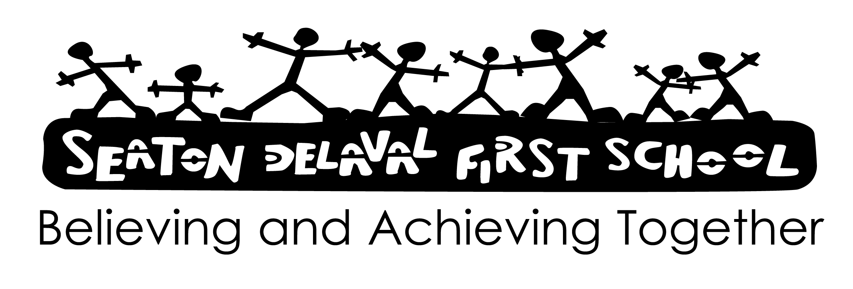

Signed:

Dated: July 2025

Review: July 2026 [or sooner if required]

Early Years Foundation Stage

We acknowledge the statement that ‘the period from birth to five is one of rapid growth and development – physical, emotional, moral and intellectual. At this stage children’s development needs are complex and inter-related’. (Staring with Quality – DES 1990)

We believe it is essential to create an environment of emotional warmth, with consistent praise and encouragement, so that each child feels individually valued, well motivated and confident to meet new challenges and reach our high expectations with a sense of achievement.

We want all of our children to be successful learners, to be confident individuals and to become responsible citizens (Every Child Matters).

We believe the Early Years Foundation Stage/ Phase, which covers the development of children between the ages of three and five years, is important because it is in the foundation years that children develop learning attitudes, skills, concepts, knowledge, social integration and personal organisation. We see play as a central tool for learning as it is a key way in which young children learn with enjoyment and challenge.

The Early Years Foundation Stage is based on four main principles namely:
- A Unique Child
- Positive Relationships
- Enabling Environments
- Learning and Development

Characteristics of effective learning are:
- Playing and exploring – engagement (Finding out and exploring; Playing with what they know; Being willing to ‘have a go’)
- Active learning – motivation (Being involved and concentrating; Keeping trying; Enjoying achieving what they set out to do)
- Creating and thinking critically – thinking (Having their own ideas; Making links; Choosing ways to do things)

The Early Years Foundation Stage curriculum is organised into seven areas of learning:
Prime Areas –
Personal, Social and Emotional Development;
Communication and Language;
Physical Development.
Specific Areas –
Literacy;
Mathematics;
Understanding the World;
Expressive Arts and Design.

We believe learning is holistic and cannot be compartmentalised. One experience may provide children with opportunities to develop a range of competencies, skills and concepts across several areas of learning. Each area of learning works towards a number of relevant Early Learning Goals, which most children are expected to achieve by the end of the Early Years Foundation Stage.

Aims:
- To promote the social, emotional, physical, spiritual and intellectual development of each child.
- To provide a stimulating and safe environment for learning where children can engage in first hand experiences.
- To support and extend children’s learning through purposeful observation, evaluation and interaction.

Procedure:
Role of the Governing Body
- The GB has:
- appointed a member of staff to be the Early Years Foundation Stage Team Leader;
- nominated a link governor to visit the school regularly, to liaise with the Early Years Foundation Stage Team Leader and to report back to the GB.
Role of the Early Years Foundation Stage Team Leader
- The Early Years Foundation Stage Team Leader will:
- lead the development of the Foundation Stage;
- contribute areas to improve for the School Development Plan;
- work with the SLT and Subject Leaders;
- work with external consultants to improve provision;
- provide guidance and support to all staff;
- keep up to date with new developments and resources;
- review and monitor by discussion with staff;
- annually report to the GB on the success and development of the Early Years Foundation Phase.
Role of Teaching and Support Staff
- The teaching and support staff work:
- together as a team in conjunction with the Early Years Foundation Stage Team Leader;
- to promote confident and independent learners;
- to encourage learners to explore, investigate and initiate;
- to create a learning environment that reflects learning across all seven areas of the curriculum.
Organisation
- The Early Years Foundation Stage Team Leader is responsible for the management of the Early Years Foundation Stage team and the Early Years Foundation Stage Area.
- The Early Years Foundation Stage covers two indoor classrooms, an outdoor classroom and an indoor activity area, and is staffed by 2 teachers, 2 nursery nurses/ HLTA and additional support staff.
Planning
- Medium term planning is completed for each new topic to be covered.
- Short term planning outlines the adult supported learning for the half term and includes Early Years Foundation Stage Development Matters Bands to be assessed for all areas of learning.
- Teachers collaborate over planning, sharing ideas for activities, resources and special events.
- Children are flexibly grouped into three key groups, which are reviewed every two weeks, according to their Development Matters Band with a further (fourth) key group to provide interventions and support.

Assessment
- Within each learning area, Development Matters Bands and Early Learning Goals establish expectations for children to work towards during the Early Years Foundation Stage.
- New pupils will be assessed within their first two weeks at school to generate a baseline record.
- The Early Years Foundation Stage Profile, which focuses on the progress along the Early Learning Goals within the seven areas of learning, is at the end of EYFS 2 (Reception).
- In October, February and June staff summarise achievement.
- Phonics/ Letters and Sounds are assessed every half term.
- EYFS 2 children will undertake a reading age standardised test in July.
- All children are assessed through a mixture of information gathering strategies – focused observations, post it notes, photographs, anecdotal evidence, child initiated play, structured tasks, discussions, etc.
Role of Parents
- We ask all parents to:
- work in partnership with the school;
- attend the induction process talks which are given to Nursery and Reception parents;
- attend informal parent workshops;
- attend termly parent-teacher consultation meetings;
- contribute to the Learning Journal;
- work with their children at home on relevant learning activities initiated by the school.
Effectiveness
- We believe this policy will be effective only if we ensure consistency across the school by regular monitoring.

