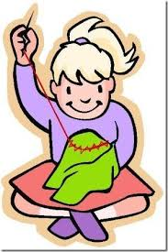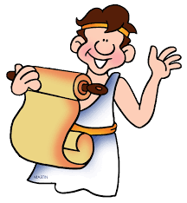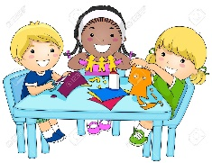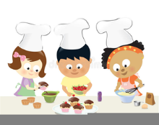

**Science**

**Plants**

Can they identify and describe the functions of different parts of flowering plants? (roots, stem/trunk, leaves and flowers)?

Can they explore the requirement of plants for life and growth (air, light, water, nutrients from soil, and room to grow)?

Can they explain how they vary from plant to plant?

Can they investigate the way in which water is transported within plants?

Can they explore the part that flowers play in the life cycle of flowering plants, including pollination, seed formation and seed dispersal?

**Animals including humans**

Can they explain the importance of a nutritionally balanced diet?

Can they describe how nutrients, water and oxygen are transported within animals and humans?

Can they identify that animals, including humans, cannot make their own food: they get nutrition from what they eat?

Can they describe and explain the skeletal system of a human?

Can they describe and explain the muscular system of a human?

Can they explain how the muscular and skeletal systems work together to create movement?

**DT**

Textiles

Can they join textiles of different types in different ways? Can they choose textiles both for their appearance and also qualities?

Do they think what the user would want when choosing textiles?

Have they thought about how to make their product strong?

Can they devise a template?

Can they explain how to join things in a different way?

**Art** Can they add onto their work to create texture and shape?

Can they work with life size materials?

Can they create pop-ups? • Can they use more than one type of stitch?

Can they join fabric together to form a quilt using padding?

Can they use sewing to add detail to a piece of work?

Can they add texture to a piece of work?

**PSHE**

**What are families like? What makes a community?**

**Computing**

Programming- Events and actions

**RE**

How do festivals and worship show what matter to Muslims?

How do festivals and family life show what matters to Jewish people?

**History**

Knowledge and interpretation

Do they appreciate that the early Brits would not have communicated as we do or have eaten as we do?

Can they begin to picture what life would have been like for the early settlers?

Can they recognise that Britain has been invaded by several different groups over time?

Do they realise that invaders in the past would have fought fiercely, using hand to hand combat?

Can they suggest why certain events happened as they did in history?

Can they suggest why certain people acted as they did in history?

**Cross Curricular Links**

**English** Playscripts, instructions, story writing.

**Maths**

Weigh& measuring linked to cooking.

Co- ordinates linked to map work.

Primary engineering programme linked to

Science and DT.

**PE**

**Dance**

Can they improvise freely, translating ideas from a stimulus into movement?

Can they share and create phrases with a partner and in small groups?

Can they repeat, remember and perform these phrases in a dance?

Games

Do they know and use rules fairly to keep games going?

Can they keep possession with some success when using equipment that is not used for throwing and catching skills?

**Geography**

Physical Geography

Can they use maps and atlases appropriately by using contents and indexes?

Can they describe how volcanoes are created?

Can they describe how earthquakes are created?

Can they confidently describe physical features in a locality?

Can they locate the Mediterranean and explain why it is a popular holiday destination?

Can they recognise the 8 points of the compass (N,NW, W, S, SW, SE, E, NE)?

Can they explain why a locality has certain physical features?

**Music** Composing [including notation]

Can they use different elements in their composition?

Can they create repeated patterns with different instruments?

Can they compose melodies and songs?

Can they create accompaniments for tunes?

Can they combine different sounds to create a specific mood or feeling?

**French Speaking** Can they have a short conversation where they are saying 2-3 things? Can they use short phrases to give a personal response?

**Year 3 Yellow**

**The Romans**

**Spring Term**