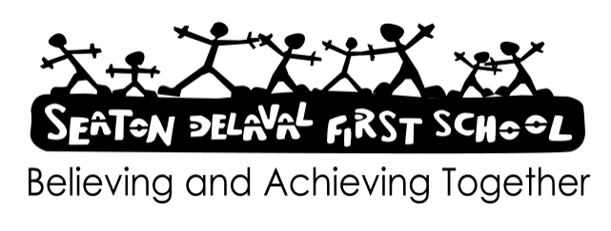

* Acceptable Use Policy [temporary or agency staff] 2025- 2026
* All users must take responsibility for their own use of new technologies, making sure that they use technology safely, responsibly and legally.
* All users must be active participants in e-safety education, taking personal responsibility for their awareness of the opportunities and risks posed by new technologies.
* No communications device, whether school provided or personally owned, may be used for the bullying or harassment of others in any form.
* No applications or services accessed by users may be used to bring the school, or its members, into disrepute.
* All users have a responsibility to report any known misuses of technology, including the unacceptable behaviours of others.
* All users have a duty to ensure confidentiality when accessing work related emails off site e.g. log off or lock screen, ensure others cannot read work related emails, regularly empty their inbox and deleted items, etc.
* All users have personal responsibility for the physical security for their device and this must not be used by family members or friends.
* All users must remove emails containing sensitive or personal identifiable data to a separate folder, once processed, to reduce the risk of unauthorised disclosure.
* All users saving attachments containing personal information should be mandated to school equipment only.
* All users have a duty to respect the technical safeguards which are in place. Any attempt to breach technical safeguards, conceal network identities, or gain unauthorised access to systems and services, is unacceptable.
* All users have a duty to report failings in technical safeguards which may become apparent when using the systems and services.
* All users have a duty to protect their passwords and personal network logins, and should log off the network when leaving workstations unattended. Any attempts to access, corrupt or destroy other users’ data, or compromise the privacy of others in any way, using any technology, is unacceptable.
* All users to be aware that any communication relating to school business must be conducted using a school email address. Use of the school email address for personal use is prohibited.
* All users should use network resources responsibly. Wasting staff effort or networked resources, or using the resources in such a way so as to diminish the service for other network users, is unacceptable.
* All users should understand that network activity and online communications are monitored, including any personal and private communications made via the school network.
* All users should be aware that in certain circumstances where unacceptable use is suspected, enhanced monitoring and procedures may come into action, including the power to check and/or confiscate personal technologies such as mobile phones.
* All users must take responsibility for reading and upholding the standards laid out in the AUP.
* All users should understand that the AUP is regularly reviewed and consistently enforced.
* School personnel will:
* comply with all aspects of this policy
* not access social networking sites during the school day;
* not post confidential school information or information about any member of the school personnel on any social networking site;
* not make reference to the school or anyone connected to it when using any social networking site;
* not bring the school into disrepute by making any derogatory, defamatory, discriminatory or offensive comments on any social networking site;
* not make discriminatory or offensive comments about any member of the school personnel on any social networking site;
* be aware that the Governing Body will take the necessary disciplinary action if any member of the school personnel breaches this policy.

I will comply with the NCC Social Network Policy and Guidance and the DfE guidance specific to school staff.

* I will not make or accept friend requests or have any contact on social media with pupils or their siblings even after they have left the school.
* I will be cautious about having parents as friends as this could compromise my independence.
* I will use the highest possible privacy settings
* I will avoid being ‘tagged’ in inappropriate pictures
* I will not post content which may be libellous or bring the school into disrepute
* I will not post content which may be seen as the opinion of the school.
* I will not have the name of the school on my personal profile.
* Signed:
* Date: June/ July 2025
* Review: July 2026/ September 2026

|  |  |  |
| --- | --- | --- |
| Name | Signature | Date |
|  |  |  |
|  |  |  |
|  |  |  |
|  |  |  |
|  |  |  |
|  |  |  |
|  |  |  |
|  |  |  |
|  |  |  |
|  |  |  |
|  |  |  |
|  |  |  |
|  |  |  |
|  |  |  |
|  |  |  |
|  |  |  |
|  |  |  |

|  |  |  |
| --- | --- | --- |
| Name | Signature | Date |
|  |  |  |
|  |  |  |
|  |  |  |
|  |  |  |
|  |  |  |
|  |  |  |
|  |  |  |
|  |  |  |
|  |  |  |
|  |  |  |
|  |  |  |
|  |  |  |
|  |  |  |
|  |  |  |
|  |  |  |
|  |  |  |
|  |  |  |
|  |  |  |
|  |  |  |