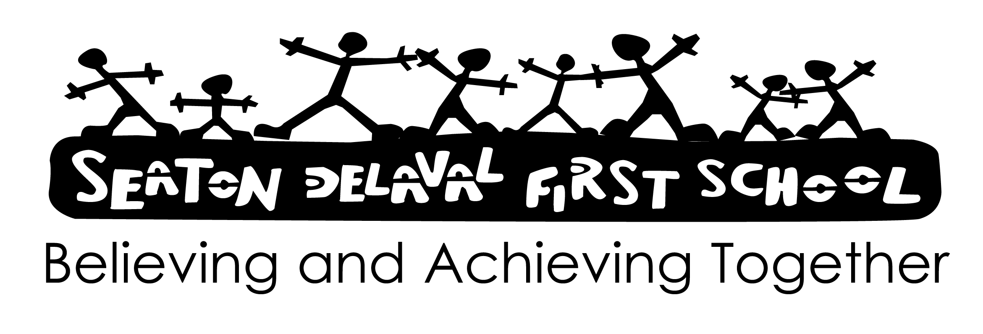

Signed:

Date: February 2025

Review: February 2028

School Travel Plan

We have in place a School Travel Plan which aims to improve the journey to school for pupils, parents and school personnel by identifying safe, healthy and sustainable alternative ways of travelling rather than using cars as a means of transport.

The plan has been written by pupils, school personnel, parents and governors and aims to encourage everyone to walk, cycle, use public transport or car share as a means of travelling to school.

We believe the School Travel Plan will provide many benefits to pupils and to the school. For pupils we feel there will be an improvement in their health and fitness, their road safety and personal skills, their knowledge of the local community and environment and their problem solving skills.

The school will benefit as the School Travel Plan will reduce congestion and pollution, improve safety, and improve relationships with the local community. Also, it will help the school gain further status as a Healthy/Eco School and it will provide us with the opportunity to apply for funding to improve sustainable travel to school.

We wish to work closely with the School Council and to hear their views and opinions as we acknowledge and support Article 12 of the United Nations Convention on the Rights of the Child that children should be encouraged to form and to express their views.

Aims:
- To have in place a school travel plan in order to improve the journey to school for pupils, parents and school personnel.
- To demonstrate commitment to environmental change.
- To work with other schools in order to share good practice in order to improve this policy.

Procedure
Role of Governing Body -
The Governing Body has:
- appointed a member of staff to be to be the Coordinator for Sustainable Development who will lead the development of the School Travel Plan;
- delegated powers and responsibilities to the Headteacher to ensure all school personnel and visitors to the school are aware of and comply with this policy;
- in place a Traffic Management policy which supports Bike4Life, Walk to Schools Week and Greener Travel
- responsibility for ensuring funding is in place to support this policy;
- responsibility for ensuring policies are made available to parents;
- nominated a link governor to visit the school regularly, to liaise with the coordinator and to report back to the Governing Body;
- responsibility for the effective implementation, monitoring and evaluation of this policy.

Role of the Headteacher -
The Headteacher will:
- ensure all school personnel, pupils and parents are aware of and comply with this policy;
- establish the School Travel Plan;
- work closely with the coordinator;
- monitor the effectiveness of this policy;
- annually report to the Governing Body on the success and development of this policy.

Role of the Co-ordinator -
The coordinator will:
- lead the development of this policy throughout the school;
- work closely with the Headteacher and the nominated governor;
- provide guidance and support to all staff;
- provide training for all staff on induction and when the need arises;
- keep up to date with new developments and resources;
- review and monitor;
- annually report to the Governing Body on the success and development of this policy.

Role of the Nominated Governor -
The Nominated Governor will:
- work closely with the Headteacher and the coordinator;
- ensure this policy and other linked policies are up to date;
- ensure that everyone connected with the school is aware of this policy;
- report to the Governing Body every term;
- annually report to the Governing Body on the success and development of this policy.

Procedures in Developing a School Travel Plan -
The coordinator will organise a School Travel Plan working group involving pupils, school personnel, parents, governors the local community and the Local Authority in order to devise the School Travel Plan.
Step 1 - To establish:
- what we already have in place
- how pupils travel to school
- how they would like travel to school
- why they do not walk, cycle, use public transport or car share
- where parents go after dropping their children at school

Step 2 – To analyse the results of the surveys.

Step 3 – To write the School Travel Plan from the results of the survey and to include:
- Safer Routes to School programme
- Car Sharing Scheme
- ‘Park and Walk’ scheme
- Public Transport information
- Organising a ‘Walking Bus’
- Create pedestrian only entrances
- Build shelters for parents waiting for their children
- Continue with Bike4Life scheme
- Build cycle storage facilities

Step 4 – Advertise the School Travel Plan
- To everyone connected with the school
- On the school website
- In school welcome packs
- In the school prospectus
- In the local press

Role of School Personnel -
School personnel will:
- comply with all aspects of this policy
- undertake appropriate training.

Role of Pupils -
Pupils will be aware of and comply with this policy

Role of the School Council -
The School Council will be involved in:
- determining this policy with the Governing Body;
- discussing improvements to this policy during the school year;
- reviewing the effectiveness of this policy with the Governing Body.

Role of Parents -
Parents/carers will be aware of and comply with this policy.

Raising awareness of this policy -
We will raise awareness of this policy via:
- the School Handbook/Prospectus
- the school website
- the Staff Handbook
- meetings with parents such as introductory, transition, parent-teacher consultations and periodic curriculum workshops
- school events
- meetings with school personnel
- communications with home such as weekly newsletters and of end of half term newsletters
- reports such annual report to parents and Headteacher reports to the Governing Body
- information displays in the main school entrance.

Monitoring the effectiveness of this policy -
Annually (or when the need arises) the effectiveness of this policy will be reviewed by the coordinator, the Headteacher and the nominated governor and the necessary recommendations for improvement will be made to the Governors.

