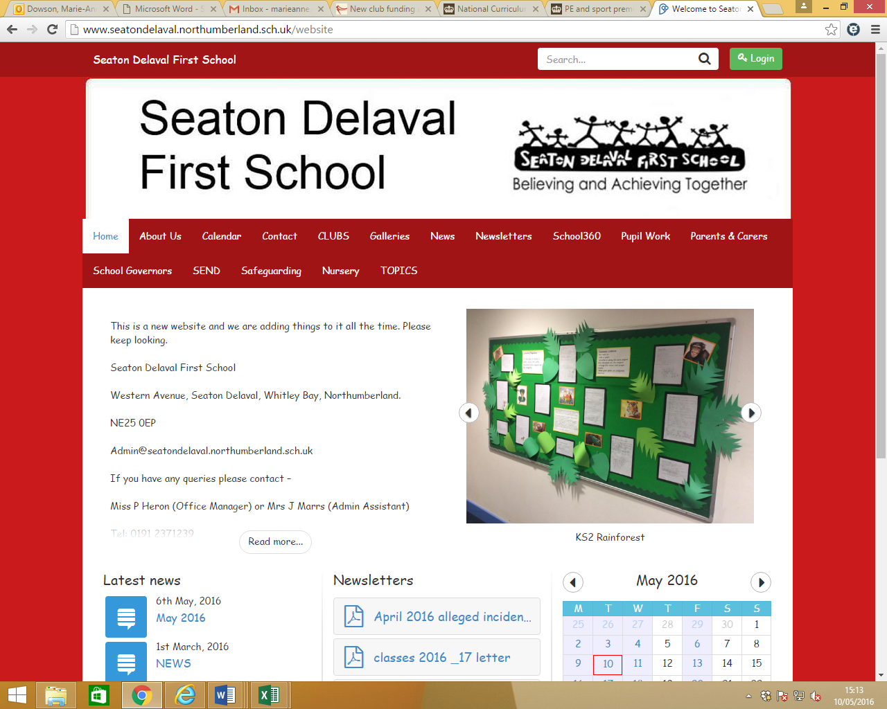

**Seaton Delaval First School Accessibility Plan**

3-year period covered by the plan: 2025-2028.

The priorities set below are to be achieved within the timescale of this reporting cycle.

**Introduction**

The SEN and Disability Act 2001/10 extended the Disability Discrimination Act 1995 (DDA) to cover education. Since September 2002, the Governing Body has had three key duties towards disabled pupils, under Part 4 of the DDA:

* not to treat disabled pupils less favourably for a reason related to their disability;
* to make reasonable adjustments for disabled pupils, so that they are not at a substantial disadvantage;
* to plan to increase access to education for disabled pupils.

The Equality Act 2010 replaced all existing equality legislation, including the Disability Discrimination Act.

According to the Equality Act 2010 a person has a disability if:

(a) He or she has a physical or mental impairment, and

(b) The impairment has a substantial and long-term adverse effect on his or her ability to carry out normal day-to-day activities.

The government’s definition of disability and long-term adverse effects can be read in full [here](https://www.gov.uk/definition-of-disability-under-equality-act-2010).

The Accessibility Plan is structured to complement and support the school’s Equality Objectives, and these are also published on the school website.

This plan sets out the proposals of the Governing Body of the school to increase access to education for disabled pupils in the three areas required by the planning duties:

⦁ increasing the extent to which disabled pupils can participate in the school **curriculum**;

⦁ improving the **environment** of the school to increase the extent to which disabled pupils can take advantage of education and associated services;

⦁ improving the delivery to disabled pupils of any **information which is provided in writing**.

It is a requirement that the school’s accessibility plan is resourced, implemented and reviewed and revised as necessary. What follows are our action plans showing how the school will address the most urgent, new priorities identified and how we will resource and implement them.

**Vision and Values**

We know that we can best achieve our aims by working in close partnership with families and our communities. We recognise that the school is at the heart of the local community, and we strive to maintain and develop as many links as possible with people and services around us.

At the present time our main focus centres on developing as a school which works in partnership with and is accountable to the community it serves. We are committed to giving all our children every opportunity to participate in school and community life. This plan helps to ensure that this happens for all children in our school who have disabilities. Inclusion considers a child’s protected characteristics, disability and vulnerability.

With a relatively small cohort of children, it is rare that we support children with an a physical disability. We maintain accessible buildings and facilities and ensure that staff have training and CPD to be able to make anticipatory adjustments when required.

**Developing the plan: consultation**

The priorities for the Accessibility Plan for the school were identified by:

⦁ The Governing Body

⦁ Headteacher (in consultation with children, parents and carers)

⦁ SEND Co

⦁ School Improvement Partner from Northumberland County Council

**Increasing the extent to which disabled pupils can access the school curriculum**

**Transition points, differentiation and self-regulation.**

With the support of the High Incidence Needs Team (HINT), we have accessed valuable support to ensure that staff are equipped to facilitate sensory processing techniques, have autism awareness and offer Speech and Language interventions to help children regulate and access the curriculum.

Therapeutic interventions are intended to help children with learning disabilities to self-regulate and be able to learn. We really do aim to know our children ‘inside out’ and this is helped by the small class sizes and the length of time children stay in a mixed-age teaching environment. However, we do face challenges;

* Mixed ages and abilities in classrooms mean that class teachers must hone and refine differentiation by ability as well as age.
* The composition of our classes might be affected by children of very different ages (e.g summer birthdays) and abilities at the points of transition.
* We aim to work to further embed and develop the strong focus we have on metacognitive strategies with the aim of building resilience and helping children with disabilities to move seamlessly through transition points through work on friendships, strategies and resources designed to support and enhance learning.
* Over the three years of this strategy we will refine and reflect on the most successful elements of the plans such as those promoting social interaction, resilience, emotional wellbeing and metacognition.

**Improving the physical environment of the school to increase the extent to which disabled pupils can take advantage of education and associated services:**

**An enabling environment**

Our school site currently meets the accessibility needs of all of the pupils and community partners who use it.

Any improvements we make to the physical environment are constrained by financial limitations, however the following plans are in place for this cycle and all contribute to making the school more accessible to people with disabilities.

These will include:

Sensory needs profiles for neurodivergent children who find areas of the school environment challenging.

An ongoing commitment to meet the changing needs of children who have sensory bias, avoidant and restrictive diets and who are at risk of not being able to access the food we prepare in accordance with the school food standards and within budgetary constraints. Imaginative, bespoke approaches and willingness to learn will help us achieve this objective.

**Improving the delivery to disabled pupils of information that is provided in written formats.**

**Specific Strategies for Specific Learning Disabilities:**

* **Dyslexia:** Use multisensory approaches to teaching literacy, such as incorporating visual, auditory, and kinesthetic activities. Provide explicit instruction in phonics and phonological awareness.
* **Dysgraphia:** Offer alternative methods for completing written tasks, such as using a computer or voice recorder. Provide assistive technology for handwriting support.
* **ADHD:** Minimize distractions in the learning environment and break down tasks into smaller chunks. Use visual timers and checklists to help students stay focused.
* **Auditory Processing Disorder:** Provide clear and concise instructions. Use visual aids and repeat key information. Reduce background noise in the classroom.

We will continue to collaborate with High and Low Incidence Needs Teams to ensure that children have access to technology, therapies and aids to learning that make the written word more accessible.

**Appendix 1: Useful resources**

Making printed information accessible.

Resources and guidance: [Accessible Communication Formats](https://www.gov.uk/government/publications/inclusive-communication/accessible-communication-formats) (Government guidance)

[Creating accessible documents](https://abilitynet.org.uk/factsheets/creating-accessible-documents-0) factsheet (Abilitynet)

[Abilities and assistive technology](https://www.ukaaf.org/abilities/) (UK Association for Accessible Formats)

[The Sensory Trust information sheet on clear and large print](https://www.sensorytrust.org.uk/resources/guidance/designing-with-clear-and-large-print)

[Dyslexia Style Guide](https://www.bdadyslexia.org.uk/advice/employers/creating-a-dyslexia-friendly-workplace/dyslexia-friendly-style-guide) (British Dyslexia Association)

[What Works?](https://ican.org.uk/i-cans-talking-point/professionals/tct-resources/what-works-database/) (A database of evidence based resources for professionals from the Communication Trust)

[Custom eyes](https://www.guidedogs.org.uk/getting-support/help-for-children-and-families/living-independently/customeyes-books/) Schools and individuals can join the scheme which can reprint (at RRP) large print tailor made books which include:

● picture books

● fiction

● non-fiction

● Oxford Reading Tree

[Northumberland County Blind Association](http://www.ncba.org.uk/page/transcription-services) undertake commissions to transcribe documentation to Braille.

[Easy Read UK](https://www.easyreaduk.co.uk/our-services/creating-easy-read-documents/) can convert documents to Easy Read format.

**Building design and sensory preferences**

[Audit tool for sensory preferences](https://bbc.github.io/uxd-cognitive/)

If the sensory responses and preferences of Neurodiverse communities are better understood it will be possible to create shared environments that more closely meet everyone’s needs. There is an online audit tool hosted by the BBC to ensuring that building design considers physical accessibility for neurodivergent people.