**CHILD PROTECTION AND SAFEGUARDING POLICY**

Seaton Delaval First School

|  |  |  |  |
| --- | --- | --- | --- |
| **Policy Location:** | **Reviewed:** | **Review Due:** | **Person Responsible:** |
| Seaton Delaval First School/ Safeguarding Library | September 2025 | September 2026 | O Flitcroft, DSL + CoG |

**This policy is available on the school website and is referenced in our staff handbook [GSWP] as well as being available electronically, it is also made available to all visitors.**

Contents

1. Policy statement and principles p4
2. Roles and responsibilities p5
3. Children Protection Procedures- Recognising, responding and reporting Procedures p11
   1. Recognising abuse
   2. Contextual Safeguarding
   3. Impact of abuse
   4. Responding and Procedures
   5. If a pupil discloses to you
   6. Notifying parents
   7. Referral to social care
   8. Child’s wishes
4. Adults working in school p7
   1. Good practice guidelines and code of conduct
   2. School Central Record (SCR)
   3. Abuse of a position of trust
   4. Complaints Procedure
   5. Whistleblowing
   6. Allegations or concerns about an adult
   7. Training
   8. Visitors
   9. Safer Recruitment
   10. Regulated Activity, Volunteers, Contractors
   11. Site Security
   12. Extended school, out of school providers and off-site arrangements
5. Searching and Screening
6. Physical Intervention
7. Digital Safety pg 10
   1. Digital Safety overview
   2. Photography and images
   3. Staff/pupil relationships and online contact
8. Our curriculum -Helping Children to keep themselves safe pg 14

|  |  |
| --- | --- |
| **APPENDICES** | |
| **A** | **DSL Share drive and important links** |
| **B** | **Definitions of Abuse and Other Harmful Behaviour** |
| **C** | **Indicators of abuse** |
| **D** | **Pupils more vulnerable/at greater risk** |
| **E** | **Specific Considerations-** |
| **F** | **School Paperwork for Recording & Reporting Concerns** |
| **G** | **Flowchart for following up concerns** |
| **H** | **Flowchart for dealing with sexual violence and sexual harm** |
| **I** | **Standards for Effective Child Protection Practice in Schools- OFSTED** |
| **J** | **Dealing with Allegations Against People Who Work with Children** |
| **L** | **Mental Health Pathways and Signposting** |
| **M** | **Attendance Responsibilities** |
| **O** | **KCSiE 2025 - Summary of Changes** |
| **P** | **NCASP Priorities & training recommendations** |
| **Q** | **Contextual Safeguarding Links- Victims Offenders List (VOL)** |
| **R** | **Offensive Weapon and Knife Carrying- School protocol (inc searching and screening)** |
| **S** | **Northumberland Family Hubs- information and support** |
| **T** | **Frequently asked questions- Quick Reminder** |
| **U** | **Key Contacts** |

SEATON DELAVAL FIRST School fully recognises its responsibility for safeguarding and promoting the welfare of children. This policy has been developed from policy, processes and protocol as stated in these national documents:

* Working together to safeguard children- December 2023 <https://assets.publishing.service.gov.uk/media/65cb4349a7ded0000c79e4e1/Working_together_to_safeguard_children_2023_-_statutory_guidance.pdf>
* KCSiE 2025 [Keeping children safe in education - GOV.UK (www.gov.uk)](https://www.gov.uk/government/publications/keeping-children-safe-in-education--2)
* Use of Reasonable Force <https://assets.publishing.service.gov.uk/media/5a819959ed915d74e6233224/Use_of_reasonable_force_advice_Reviewed_July_2015.pdf>
* Mobile Phones in Schools <https://assets.publishing.service.gov.uk/media/65cf5f2a4239310011b7b916/Mobile_phones_in_schools_guidance.pdf>
* School Attendance Responsibilities [Working together to improve school attendance - GOV.UK (www.gov.uk)](https://www.gov.uk/government/publications/working-together-to-improve-school-attendance)

This policy (* these policies are statutory) is one of a series in the school’s safeguarding portfolio which includes:

* Staff behaviour/code of conduct/ GSWP
* Physical intervention and the use of reasonable force/ restraint
* Behaviour *
* Attendance
* School Suspensions & Exclusions*
* Personal and intimate care
* Complaints procedure
* Anti-bullying
* KCSiE
* Safe working practice
* Whistleblowing
* SEND*
* Missing children
* Sick Children
* Uncollected Children
* Recruitment and selection (with reference to the single central record*)
* Managing allegations
* Staff discipline, grievance and disciplinary*
* Student Checks
* Acceptable Use Policy
* Online Safety
* Home Tuition
* Confidentiality and information sharing
* Children Missing Education
* Children with Health Needs/ Medical Conditions who cannot attend school*
* Supporting Pupils with Medical Conditions*
* Relationships & Sex education*
* Complaints procedure*
* First Aid*
* Health and Safety*
* Equality Information and Objectives*
* LGBTIQ
* PREVENT/ Radicalisation and Extremism

**Policy statement and principles**

**Child protection statement**

We recognise our moral and statutory responsibility to safeguard and promote the welfare of all pupils. We endeavour to provide a safe and welcoming environment where children are respected and valued. We are alert to the signs of abuse and neglect and follow procedures to ensure that children receive effective support and protection.

At SEATON DELAVAL FIRST school pupils are taught about safeguarding, including online, through various teaching and learning opportunities and the school is fully committed to this as part of the delivery of a broad and balanced curriculum.

This policy has been written with reference to key statutory guidance (as referenced throughout). The procedures contained in this policy apply to all staff, volunteers, visitors and governors and are consistent with those of the local safeguarding partnership, Northumberland Children’s and Adults Safeguarding Partnership (NCASP). This policy was developed, and references arrangements, with the 3 safeguarding partners (the local authority, the integrated care board & the police).

Early years settings, schools and further education and skills providers should be safe environments where children/learners and vulnerable adults can learn and develop. Timely and appropriate safeguarding action is taken for children/learners who need early help or who may be suffering, or likely to suffer, harm.

School policy and practice is also established to meet the requirements set out by our safeguarding partners Northumberland Children’s and Adult’s Strategic Safeguarding Partnership (NCASP)

**Policy aims**

* To demonstrate the school’s commitment regarding safeguarding and child protection to pupils, parents and other partners
* To provide all staff with the necessary information to enable them to meet their child protection responsibilities
* To ensure consistent good practice
* To maintain the highest standard of a culture of safeguarding within SEATON DELAVAL FIRST School

**Our principles**

* The welfare of the child is paramount
* All children, regardless of age, gender, ability, culture, race, language, religion or sexual identity, have equal rights to protection
* The school’s responsibility to safeguard and promote the welfare of children is of paramount importance
* The school will maintain an attitude of “**it could happen here**”
* All staff have an equal responsibility to act on any suspicion or disclosure that may suggest a child is at risk of harm
* Pupils and staff involved in child protection issues will receive appropriate support

*This policy will be reviewed at least annually unless an incident or new legislation or guidance suggests the need for an interim review to ensure our practice and procedures are the most effective they can be.*

**Roles and responsibilities**

The named designated safeguarding lead (DSL) is: O Flitcroft

The deputy designated safeguarding leads are: A Brown

The nominated child protection governor is: A McGougan

Contact details for NCC: One Call 01670 536400 School's Safeguarding Team Tues to Wed 07731007896 or use individual team members contact details

**Our responsibilities**

As a school we will promote a culture of safeguarding through effective training, briefings, policy and practice as well as collaborative multiagency working. Staff working directly with children will all have read Part 1 and Annex B of KCSiE annually. Those who do not work directly with children will have read Part 1 OR Annex A annually.

**All staff**

Due to their day-to-day contact with pupils, school staff are uniquely placed to observe changes in children’s behaviour and the outward signs of abuse. Children may also turn to a trusted adult in school when they are in distress or at risk. It is vital that **all school staff** are alert to the signs of harm (inside/outside or the home, at school and online), are available to listen to, reassure and keep pupils safe. All staff will understand the procedures for reporting concerns.

All staff should be aware that children may not feel ready or know how to tell someone that they are being abused, exploited, or neglected, and/or they may not recognise their experiences as harmful. This could be due to their vulnerability, disability and/or sexual orientation or language barriers. This should not prevent staff from having a professional curiosity and speaking to the DSL (Designated Safeguarding Leads) if they have concerns about a child. It is also important that staff determine how best to build trusted relationships with children which facilitate communication.

**Designated Safeguarding Lead Responsibilities (further to Annex C: KCSiE 2025 pg 171)**

The DSL is a member of the senior leadership team (SLT). They take the lead responsibility for child protection and wider safeguarding in school. The DSL:

* **has the time, training, resources and support to:**
  + act as a source of support and expertise to the school community
  + encourage a culture of listening to children and taking account of their wishes and feelings
  + follow locally agreed processes for providing early help and intervention
  + refers cases of suspected abuse to children’s social care or police, as appropriate
  + notify children’s social care if a child with a child protection plan has unexplained absences
  + keep detailed written records of all concerns, ensuring that such records are stored securely
  + develop effective links with relevant statutory and voluntary agencies including the NCASP
  + be the lead for Operation Encompass and Operation Endeavour in the school
  + attend and contribute to child protection conferences, plans and communicating these appropriately
  + have a working knowledge of Northumberland Children and Adult Safeguarding Partnership (NCASP) procedures [Northumberland Children's Services Procedures Manual (proceduresonline.com)](https://www.proceduresonline.com/northumberlandcs/)
  + liaise with the nominated governor and headteacher (where the role is not carried out by the headteacher)
  + reports concerns that a pupil may be at risk of radicalisation or involvement in terrorism, following the Prevent referral process

**Wider responsibilities of the DSL include:**

* ensuring that the child protection policy and procedures are regularly reviewed and updated annually, working with governors and trustees
* makes the child protection & safeguarding policy available publicly, on the school’s website
* ensuring that when a pupil leaves the school, their child protection file is sent securely to the new school (separately from the main pupil file and ensuring secure transit) and confirmation of receipt is obtained. The pupil’s social worker should also be informed of the change in school
* ensuring parents are aware of the school’s role in safeguarding and that referrals will be made
* working with others to ensure that the school’s filtering and monitoring systems are functional and effective

**Training responsibilities:**

* is appropriately trained, receiving annual updates and refresher training provided by the Local Authority (every 2 years)
* ensures a record of staff compliance for child protection and safeguarding training
* ensures staff are kept up to date with key priorities within the LA, including learning from serious practice reviews

Whilst the activities of the designated safeguarding lead can be delegated to appropriately trained deputies, the ultimate lead responsibility for child protection, as set out above, remains with the designated safeguarding lead; this lead responsibility should not be delegated.

**The deputy designated person(s):**

Is/are appropriately trained and, in the absence of the designated person, carries out those functions necessary to ensure the ongoing safety and protection of pupils. In the event of the long-term absence of the designated person, the deputy will assume all the functions above.

**If the DSL (or deputy) are not available, staff should contact a member of the leadership team to seek advice. DSLs can also be approached in other settings if urgent.**

**Advice can also be sought from One Call 01670 536400 or from the Schools’ Safeguarding Team**

**The governing body:**

**Ensures that:**

* there is a whole-school approach to safeguarding and an active culture of keeping children safe- onsite, offsite and online
* this policy is at the forefront of, and underpins the strategic and operational running of the school
* this policy is evaluated, complies with the law and holds the school to account for the implementation
* an appointed member of the governing body monitors the effectiveness of the school's policy and procedures
* all staff, inc. the governing body, reads KCSiE and undertake relevant training in line with safeguarding partners requirements

**Specifically:**

* The DSL has appropriate time, funding, training, resources and support to fulfil the role
* The DSL has the lead authority for safeguarding, including online
* The school has effective filtering and monitoring systems in place
* The school has procedures to manage any safeguarding concerns (no matter how small) or allegations that do not meet the harm threshold (low level concerns) about staff, supply staff, volunteers and contractors
* The policy highlights and considers the additional measures required to those who are most vulnerable- SEND, LGBTQ+, children with a social worker, children missing education
* The governing body reviews the effectiveness of the curriculum in teaching children how to keep themselves safe.

**In addition- the school being used by other services and providers:**

* Assurances should be sought that the provider has appropriate safeguarding and child protection policies and procedures in place
* Ensure the school has relevant arrangements to liaise with the provider following any concerns, as well as ensuring the school understands their responsibility to follow any concerns up that happen on the premises
* Ensure the condition of use/lease of the school/setting is conditional that all safeguarding requirements are met

The chair of governors will act as the ‘case manager’ in the event that an allegation of abuse is made against the headteacher.

It is the responsibility of the governing body to ensure that the school’s safeguarding, recruitment and managing allegations procedures take into account the procedures and practice of the local authority, NCASP and national guidance.

The S175 audit must be completed annually and reviewed termly. This must be shared with the governing body.

**The head teacher:**

* ensures that the safeguarding and child protection policy and procedures are implemented and followed by all staff
* develops and maintain a culture of safeguarding across the setting through policy, practice, training and briefings
* communicates this policy to the whole school community-inc parents and carers (and pupils where appropriate)
* allocates sufficient time, training, support and resources to enable the DSL/s to carry out their roles effectively
* ensures that all staff feel able to raise concerns about poor or unsafe practice and that such concerns are handled sensitively and in accordance with the whistle blowing procedures- making decision if the harm threshold has been met or not met (low level concerns)
* ensures that pupils are provided with opportunities throughout the curriculum to learn and talk about safeguarding- at home, school, in the community and online
* ensures that anyone who has harmed or may pose a risk to a child is referred to the Disclosure and Barring Service.

**The Virtual School Head Teacher**

Virtual school head teachers have a non-statutory responsibility for the strategic oversight of the educational attendance, attainment and progress of all pupils with a social worker.

**Confidentiality**

* Timely information sharing is essential to effective safeguarding
* Fears about sharing information must not be allowed to stand in the way of the need to promote the welfare, and protect the safety, of children
* The Data Protection Act (DPA) 2018 and UK GDPR do not prevent, or limit, the sharing of information for the purposes of keeping children safe
* If staff need to share ‘special category personal data’, the DPA 2018 contains ‘safeguarding of children and individuals at risk’ as a processing condition that allows practitioners to share information without consent if: it is not possible to gain consent; it cannot be reasonably expected that a practitioner gains consent; or if to gain consent would place a child at risk
* Staff should never promise a child that they will not tell anyone about a report of abuse, as this may not be in the child’s best interests
* If a victim asks the school not to tell anyone about the sexual violence or sexual harassment:
  + There’s no definitive answer, because even if a victim doesn’t consent to sharing information, staff may still lawfully share it if there’s another legal basis under the UK GDPR that applies
  + The DSL will have to balance the victim’s wishes against their duty to protect the victim and other children
  + The DSL should consider that:
  + Parents or carers should normally be informed (unless this would put the victim at greater risk)
  + The basic safeguarding principle is: if a child is at risk of harm, is in immediate danger, or has been harmed, a referral should be made to local authority children’s social care
  + Rape, assault by penetration and sexual assault are crimes. Where a report of rape, assault by penetration or sexual assault is made, this should be referred to the police. While the age of criminal responsibility is 10, if the alleged perpetrator is under 10, the starting principle of referring to the police remains
* Regarding anonymity, all staff will:
  + Be aware of anonymity, witness support and the criminal process in general where an allegation of sexual violence or sexual harassment is progressing through the criminal justice system
  + Do all they reasonably can to protect the anonymity of any children involved in any report of sexual violence or sexual harassment – for example, carefully considering which staff should know about the report, and any support for children involved
  + Consider the potential impact of social media in facilitating the spreading of rumours and exposing victims’ identities
* The governments [information sharing advice for safeguarding practitioners](https://www.gov.uk/government/publications/safeguarding-practitioners-information-sharing-advice) include 7 ‘golden rules’ for sharing information, and will support staff who have to make decisions about sharing information
* If staff are in any doubt about sharing information, they should speak to the DSL (or deputy)

**Recognising and Responding**

**Recognising abuse**

To ensure that our pupils are protected from harm. Our staff understand what types of behaviour constitute abuse and neglect; this is included in annual training. All staff are aware that the following pupils will need help:

* Is disabled
* Has special educational needs (whether or not they have a statutory education health and care plan)
* Is a young carer
* Is bereaved
* Is showing signs of being drawn into anti-social or criminal behaviour, including being affected by gangs and county lines and organised crime groups and/or serious violence, including knife crime
* Is frequently missing/goes missing from care or home
* Is at risk of modern slavery, trafficking, sexual and/or criminal exploitation
* Is at risk of being radicalised or exploited
* Is viewing problematic and/or inappropriate online content (for example, linked to violence), or developing inappropriate relationships online
* Is in a family circumstance presenting challenges for the child, such as drug and alcohol misuse, adult mental health issues and domestic abuse
* Is misusing drugs or alcohol
* Is suffering from mental ill health
* Has returned home to their family from care
* Is at risk of so-called ‘honour’-based abuse such as female genital mutilation or forced marriage
* Is a privately fostered child
* Has a parent or carer in custody
* Is missing education, or persistently absent from school, or not in receipt of full-time education
* Has experienced multiple suspensions and is at risk of, or has been permanently excluded

Abuse may be committed by adult men or women and by other children. Harm can include ill treatment that is not physical as well as the impact of witnessing ill treatment of others. This can be particularly relevant, for example, in relation to the impact on children of all forms of domestic abuse.

The four types of abuse are **physical, sexual, emotional and neglect**. Details around each type of abuse can be found in Appendix 2.

Children can be at risk of abuse or exploitation in situations outside their families. Extra-familial harms take a variety of different forms and children can be vulnerable to multiple harms including (but not limited to) sexual abuse (including harassment and exploitation), domestic abuse in their own intimate relationships (teenage relationship abuse), criminal exploitation, serious youth violence, county lines, and radicalisation. This **is sometimes referred to as contextual safeguarding**

Child abuse is devastating for the child and can also result in distress and anxiety for staff who become involved.

We will support pupils, their families, and staff by:

* taking all suspicions and disclosures seriously
* responding sympathetically to any request from pupils or staff for time out to deal with distress or anxiety
* maintaining confidentiality and sharing information on a need-to-know basis only with relevant individuals and agencies
* storing records securely
* offering details of helplines, counselling or other avenues of external support
* where a member of staff is the subject of an allegation made by a pupil, ensure that lines of communication are maintained
* following the procedures laid down in our child protection, whistleblowing, complaints and disciplinary procedures
* cooperating fully with relevant statutory agencies
* providing access to supervision for those staff dealing with child protection issues

**Contextual Safeguarding**

Safeguarding incidents and/or behaviours can be associated with factors outside the school or college and/or can occur between children outside the school or college. All staff, but especially the designated safeguarding lead (and deputies) should be considering the context within which such incidents and/or behaviours occur. This is known as contextual safeguarding, which simply means assessments of children should consider whether wider environmental factors are present in a child’s life that are a threat to their safety and/or welfare. Children’s social care assessments should consider such factors, so it is important that schools and colleges provide as much information as possible as part of the referral process. This will allow any assessment to consider all the available evidence and the full context of any abuse. See Appendix A for additional information regarding contextual safeguarding

**Impact of abuse**

The impact of child abuse, neglect and exploitation should not be underestimated. Many children do recover well and go on to lead healthy, happy and productive lives, although most adult survivors agree that the emotional scars remain, however well buried. For some children, full recovery is beyond their reach, and the rest of their childhood and their adulthood may be characterised by anxiety or depression, self-harm, eating disorders, alcohol and substance misuse, unequal and destructive relationships and long-term medical or psychiatric difficulties.

**Any child, in any family, in any school could become a victim of abuse. Staff should always maintain an attitude of “it could happen here”.**

**Responding and Procedures**

***If a child is suffering or likely to suffer harm, or in immediate danger***

Make a referral to children’s social care and/or the police **immediately** if you believe a child is suffering or likely to suffer from harm or is in immediate danger. **Anyone can make a referral.**

Tell the DSL as soon as possible if you make a referral directly.

* Contact police 999 or Onecall 01670 536400
* Complete a Multi-Agency Referral Form (MARF) using the following link: [Multi Agency Referral Form](https://form.northumberland.gov.uk/form/auto/multi_agency_ref_form)
* Ensure any referral has been acknowledged by safeguarding partners

***If a child makes a disclosure to you***

If a child discloses a safeguarding issue to you, you should:

* Listen to and believe them. Allow them time to talk freely and do not ask **leading** questions
* Stay calm and do not show that you are shocked or upset
* Tell the child they have done the right thing in telling you. Do not tell them they should have told you sooner
* Explain what will happen next and that you will have to pass this information on. Do not promise to keep it a secret
* Write up your conversation as soon as possible in the child’s own words. Stick to the facts, and do not put your own judgement on it
* Pass to the DSL, using the school agreed method (paper). Alternatively, if appropriate, make a referral to children’s social care and/or the police directly and tell the DSL as soon as possible that you have done so. **Aside from these people, do not disclose the information to anyone else unless told to do so by a relevant authority involved in the safeguarding process**

Bear in mind that some children may:

* Not feel ready, or know how to tell someone that they are being abused, exploited or neglected
* Not recognise their experiences as harmful
* Feel embarrassed, humiliated or threatened. This could be due to their vulnerability, disability, sexual orientation and/or language barriers

None of this should stop you from having a ‘professional curiosity’ and speaking to the DSL if you have concerns about a child.

***If you discover that FGM has taken place, or a pupil is at risk of FGM***

Keeping Children Safe in Education explains that FGM comprises “all procedures involving partial or total removal of the external female genitalia, or other injury to the female genital organs”.

FGM is illegal in the UK and a form of child abuse with long-lasting, harmful consequences. It is also known as ‘female genital cutting’, ‘circumcision’ or ‘initiation’.

**Any teacher** who either:

* Is informed by a girl under 18 that an act of FGM has been carried out on her; or
* Observes physical signs which appear to show that an act of FGM has been carried out on a girl under 18 and they have no reason to believe that the act was necessary for the girl’s physical or mental health or for purposes connected with labour or birth

Must immediately report this to the police, personally. This is a mandatory statutory duty, and teachers will face disciplinary sanctions for failing to meet it.

Unless they have been specifically told not to disclose, they should also discuss the case with the DSL and involve children’s social care as appropriate.

**Any other member of staff** who discovers that an act of FGM appears to have been carried out on a **pupil under 18** must speak to the DSL and follow our local safeguarding procedures.

The duty for teachers mentioned above does not apply in cases where a pupil is *at risk* of FGM or FGM is suspected but is not known to have been carried out. Staff should not examine pupils.

**Any member of staff** who suspects a pupil is *at risk* of FGM or suspects that FGM has been carried out should speak to the DSL and follow our local safeguarding procedures.

[Female Genital Mutilation (trixonline.co.uk)](https://nesubregion.trixonline.co.uk/chapter/female-genital-mutilation#protection-and-action-to-be-taken)

***If you have concerns about a child (as opposed to believing a child is suffering or likely to suffer from harm, or is in immediate danger)***

Where possible, speak to the DSL first to agree a course of action.

If in exceptional circumstances the DSL is not available, this should not delay appropriate action being taken. Speak to a member of the senior leadership team and/or take advice from local authority children’s social care through Onecall 01670 536400. You can also seek advice at any time from the NSPCC helpline on 0808 800 5000. Share details of any actions you take with the DSL as soon as practically possible.

**Early help assessment**

If an early help assessment is appropriate, the DSL will generally lead on liaising with other agencies and setting up an inter-agency assessment as appropriate. Staff may be required to support other agencies and professionals in an early help assessment, in some cases acting as the lead practitioner.

The DSL will keep the case under constant review and the school will consider a referral to local authority children’s social care if the situation does not seem to be improving. Timelines of interventions will be monitored and reviewed.

Concerns which do not meet the threshold for child protection intervention will be managed through the Early Help process.

**Early Help Support Request forms can be found here:**

[Northumberland County Council - Supporting families](https://www.northumberland.gov.uk/Children/Family/Support.aspx)

**Referral**

If it is appropriate to refer the case to local authority children’s social care or the police, the DSL will make the referral or support you to do so.

If you make a referral directly, you must tell the DSL as soon as possible.

The local authority will make a decision within 1 working day of a referral about what course of action to take and will let the person who made the referral know the outcome. The DSL or person who made the referral must follow up with the local authority if this information is not made available, and ensure outcomes are properly recorded.

If the child’s situation does not seem to be improving after the referral, the DSL or person who made the referral must follow local escalation procedures to ensure their concerns have been addressed and that the child’s situation improves.

[professional-disagreement-protocol.pdf (trixonline.co.uk)](https://trixcms.trixonline.co.uk/api/assets/nesubregion/8ba97e55-0dc3-41e2-91bf-cc447f9ae653/professional-disagreement-protocol.pdf)

**If you have concerns about extremism**

If a child is not suffering or likely to suffer from harm, or in immediate danger, where possible speak to the DSL first to agree a course of action.

If in exceptional circumstances the DSL is not available, this should not delay appropriate action being taken. Speak to a member of the senior leadership team and/or seek advice from local authority children’s social care. Make a referral to local authority children’s social care directly, if appropriate (see ‘Referral’ above). Inform the DSL or deputy as soon as practically possible after the referral.

Where there is a concern, the DSL will consider the level of risk and decide which agency to make a referral to. This could include [Channel](https://www.gov.uk/government/publications/channel-guidance), the government’s programme for identifying and supporting individuals at risk of being drawn into terrorism, or the local authority children’s social care team.

The DfE also has a dedicated telephone helpline, 020 7340 7264, which school staff and governors can call to raise concerns about extremism with respect to a pupil. You can also email [counter.extremism@education.gov.uk](mailto:counter.extremism@education.gov.uk). **Note that this is not for use in emergency situations.**

In an emergency, call 999 or the confidential anti-terrorist hotline on 0800 789 321 if you:

* Think someone is in immediate danger
* Think someone may be planning to travel to join an extremist group
* See or hear something that may be terrorist-related

**If you have a concern about mental health**

Mental health problems can, in some cases, be an indicator that a child has suffered or is at risk of suffering abuse, neglect or exploitation.

Staff will be alert to behavioural signs that suggest a child may be experiencing a mental health problem or be at risk of developing one.

* If you have a mental health concern about a child that is also a safeguarding concern, take immediate action.
* If you have a mental health concern that is **not** also a safeguarding concern, speak to the DSL to agree a course of action.

Refer to the Department for Education guidance on [mental health and behaviour in schools](https://www.gov.uk/government/publications/mental-health-and-behaviour-in-schools--2) for more information.

<https://www.beyounorthumberland.nhs.uk/support/professionals-support>

**Allegations of abuse made against other pupils**

We recognise that children are capable of abusing their peers. Abuse will never be tolerated or passed off as “banter”, “just having a laugh” or “part of growing up”, as this can lead to a culture of unacceptable behaviours and an unsafe environment for pupils.

We also recognise the gendered nature of child-on-child abuse. However, all child-on-child abuse is unacceptable and will be taken seriously.

Most cases of pupils hurting other pupils will be dealt with under our school’s behaviour policy, but this child protection and safeguarding policy will apply to any allegations that raise safeguarding concerns. This might include where the alleged behaviour:

* Is serious, and potentially a criminal offence
* Could put pupils in the school at risk
* Is violent
* Involves pupils being forced to use drugs or alcohol
* Involves sexual exploitation, sexual abuse or sexual harassment, such as indecent exposure, sexual assault, upskirting or sexually inappropriate pictures or videos (including the sharing of nudes and semi-nudes)

**Procedures for dealing with allegations of child-on-child abuse**

If a pupil makes an allegation of abuse against another pupil:

* You must record the allegation and tell the DSL, but do not investigate it
* The DSL will contact the local authority children’s social care team and follow its advice, as well as the police if the allegation involves a potential criminal offence
* The DSL will put a risk assessment and support plan into place for all children involved (including the victim(s), the child(ren) against whom the allegation has been made and any others affected) with a named person they can talk to if needed. This will include considering school transport as a potentially vulnerable place for a victim or alleged perpetrator(s)
* The DSL will contact the Children and Young People’s health services (CYPS), if appropriate

If the incident is a criminal offence and there are delays in the criminal process, the DSL will work closely with the police (and other agencies as required) while protecting children and/or taking any disciplinary measures against the alleged perpetrator. We will ask the police if we have any questions about the investigation.

**Creating a supportive environment in school and minimising the risk of child-on-child abuse**

We recognise the importance of taking proactive action to minimise the risk of child-on-child abuse, and of creating a supportive environment where victims feel confident in reporting incidents.

To achieve this, we will:

* Challenge any form of derogatory or sexualised language or inappropriate behaviour between peers, including requesting or sending sexual images
* Be vigilant to issues that particularly affect different genders – for example, sexualised or aggressive touching or grabbing towards female pupils, and initiation or hazing type violence with respect to boys
* Ensure our curriculum helps to educate pupils about appropriate behaviour and consent
* Ensure pupils are able to easily and confidently report abuse using our reporting systems
* Ensure staff reassure victims that they are being taken seriously
* Be alert to reports of sexual violence and/or harassment that may point to environmental or systemic problems that could be addressed by updating policies, processes and the curriculum, or could reflect wider issues in the local area that should be shared with safeguarding partners
* Support children who have witnessed sexual violence, especially rape or assault by penetration. We will do all we can to make sure the victim, alleged perpetrator(s) and any witnesses are not bullied or harassed
* Consider intra-familial harms and any necessary support for siblings following a report of sexual violence and/or harassment
* Ensure staff are trained to understand:
  + How to recognise the indicators and signs of child-on-child abuse, and know how to identify it and respond to reports
  + That even if there are no reports of child-on-child abuse in school, it does not mean it is not happening – staff should maintain an attitude of “it could happen here”
  + That if they have any concerns about a child’s welfare, they should act on them immediately rather than wait to be told, and that victims may not always make a direct report. For example:
    - Children can show signs or act in ways they hope adults will notice and react to
    - A friend may make a report
    - A member of staff may overhear a conversation
    - A child’s behaviour might indicate that something is wrong
  + That certain children may face additional barriers to telling someone because of their vulnerability, disability, gender, ethnicity and/or sexual orientation
  + That a pupil harming a peer could be a sign that the child is being abused themselves, and that this would fall under the scope of this policy
  + The important role they have to play in preventing child-on-child abuse and responding where they believe a child may be at risk from it
  + That they should speak to the DSL if they have any concerns
  + That social media is likely to play a role in the fall-out from any incident or alleged incident, including for potential contact between the victim, alleged perpetrator(s) and friends from either side

The DSL will take the lead role in any disciplining of the alleged perpetrator(s). We will provide support at the same time as taking any disciplinary action.

Disciplinary action can be taken while other investigations are going on, e.g. by the police. The fact that another body is investigating or has investigated an incident doesn’t (in itself) prevent our school from coming to its own conclusion about what happened and imposing a penalty accordingly. We will consider these matters on a case-by-case basis, taking into account whether:

* Taking action would prejudice an investigation and/or subsequent prosecution – we will liaise with the police and/or local authority children’s social care to determine this
* There are circumstances that make it unreasonable or irrational for us to reach our own view about what happened while an independent investigation is ongoing

**Sharing of nudes and semi-nudes (‘sexting’)**

This approach is based on [guidance from the UK Council for Internet Safety](https://www.gov.uk/government/publications/sharing-nudes-and-semi-nudes-advice-for-education-settings-working-with-children-and-young-people) for all staff and for [DSLs and senior leaders](https://assets.publishing.service.gov.uk/government/uploads/system/uploads/attachment_data/file/609874/6_2939_SP_NCA_Sexting_In_Schools_FINAL_Update_Jan17.pdf).

**Your responsibilities when responding to an incident**

If you are made aware of an incident involving the consensual or non-consensual sharing of nude or semi-nude images/videos (also known as ‘sexting’ or ‘youth produced sexual imagery’), you must report it to the DSL immediately.

You must **not**:

* View, copy, print, share, store or save the imagery yourself, or ask a pupil to share or download it (if you have already viewed the imagery by accident, you must report this to the DSL)
* Delete the imagery or ask the pupil to delete it
* Ask the pupil(s) who are involved in the incident to disclose information regarding the imagery (this is the DSL’s responsibility)
* Share information about the incident with other members of staff, the pupil(s) it involves or their, or other, parents and/or carers
* Say or do anything to blame or shame any children involved

You should explain that you need to report the incident and reassure the pupil(s) that they will receive support and help from the DSL.

**Initial review meeting**

Following a report of an incident, the DSL will hold an initial review meeting with appropriate school staff – this may include the staff member who reported the incident and the safeguarding or leadership team that deals with safeguarding concerns. This meeting will consider the initial evidence and aim to determine:

* Whether there is an immediate risk to pupil(s)
* If a referral needs to be made to the police and/or children’s social care
* If it is necessary to view the image(s) in order to safeguard the young person (in most cases, images or videos should not be viewed)
* What further information is required to decide on the best response
* Whether the image(s) has been shared widely and via what services and/or platforms (this may be unknown)
* Whether immediate action should be taken to delete or remove images or videos from devices or online services
* Any relevant facts about the pupils involved which would influence risk assessment
* If there is a need to contact another school, college, setting or individual
* Whether to contact parents or carers of the pupils involved (in most cases parents/carers should be involved)

The DSL will make an immediate referral to police and/or children’s social care if:

* The incident involves an adult
* There is reason to believe that a young person has been coerced, blackmailed or groomed, or if there are concerns about their capacity to consent (for example, owing to SEN)
* What the DSL knows about the images or videos suggests the content depicts sexual acts which are unusual for the young person’s developmental stage, or are violent
* The imagery involves sexual acts and any pupil in the images or videos is under 13
* The DSL has reason to believe a pupil is at immediate risk of harm owing to the sharing of nudes and semi-nudes (for example, the young person is presenting as suicidal or self-harming)

If none of the above apply then the DSL, in consultation with the headteacher and other members of staff as appropriate, may decide to respond to the incident without involving the police or children’s social care. The decision will be made and recorded in line with the procedures set out in this policy.

**Further review by the DSL**

If at the initial review stage, a decision has been made not to refer to police and/or children’s social care, the DSL will conduct a further review to establish the facts and assess the risks.

They will hold interviews with the pupils involved (if appropriate).

If at any point in the process there is a concern that a pupil has been harmed or is at risk of harm, a referral will be made to children’s social care and/or the police immediately.

**Informing parents/carers**

The DSL will inform parents/carers at an early stage and keep them involved in the process, unless there is a good reason to believe that involving them would put the pupil at risk of harm.

**Referring to the police**

If it is necessary to refer an incident to the police, this will be done through a call to 101 or 999 depending on the urgency.

**Recording incidents**

All incidents of sharing of nudes and semi-nudes,and the decisions made in responding to them, will be recorded. The record-keeping arrangements set out in section 14 of this policy also apply to recording these incidents.

**Curriculum coverage**

Pupils are taught about the issues surrounding the sharing of nudes and semi-nudesas part of our relationships and sex education and computing curriculums. Teaching covers the following in relation to the sharing of nudes and semi-nudes:

* What it is
* How it is most likely to be encountered
* The consequences of requesting, forwarding or providing such images, including when it is and is not abusive and when it may be deemed as online sexual harassment
* Issues of legality
* The risk of damage to people’s feelings and reputation

Pupils also learn the strategies and skills needed to manage:

* Specific requests or pressure to provide (or forward) such images
* The receipt of such images

This policy on the sharing of nudes and semi-nudesis also shared with pupils so they are aware of the processes the school will follow in the event of an incident.

**Reporting systems for our pupils**

Where there is a safeguarding concern, we will take the child’s wishes and feelings into account when determining what action to take and what services to provide.

We recognise the importance of ensuring pupils feel safe and comfortable to come forward and report any concerns and/or allegations.

To achieve this, we will:

* Put systems in place for pupils to confidently report abuse
* Ensure our reporting systems are well promoted, easily understood and easily accessible for pupils
* Make it clear to pupils that their concerns will be taken seriously, and that they can safely express their views and give feedback

**Notifying parents or carers**

Where appropriate, we will discuss any concerns about a child with the child’s parents or carers. The DSL will normally do this in the event of a suspicion or disclosure.

Other staff will only talk to parents or carers about any such concerns following consultation with the DSL.

If we believe that notifying the parents or carers would increase the risk to the child, we will discuss this with the local authority children’s social care team before doing so.

In the case of allegations of abuse made against other children, we will normally notify the parents or carers of all the children involved. We will think carefully about what information we provide about the other child involved, and when. We will work with the police and/or local authority children’s social care to make sure our approach to information sharing is consistent.

The DSL will, along with any relevant agencies (this will be decided on a case-by-case basis):

* Meet with the victim’s parents or carers, with the victim, to discuss what’s being put in place to safeguard them, and understand their wishes in terms of what support they may need and how the report will be progressed
* Meet with the alleged perpetrator’s parents or carers to discuss support for them, and what’s being put in place that will impact them, e.g. moving them out of classes with the victim, and the reason(s) behind any decision(s)

**Adults working in schools**

**Good practice guidelines and staff code of conduct**

To meet and maintain our responsibilities towards pupils we need to agree standards of good practice which form a code of conduct for all staff. Good practice includes, but not restricted to:

* treating all pupils with respect
* setting a good example by conducting ourselves appropriately
* involving pupils in decisions that affect them
* encouraging positive, respectful and safe behaviour among pupils
* being an active listener
* being alert to changes in pupils’ behaviour and to signs of abuse, neglect and exploitation
* recognising that challenging behaviour may be an indicator of abuse
* reading and understanding the school’s safeguarding and child protection policy, staff behaviour policy and guidance documents on wider safeguarding issues
* asking the pupil’s permission before initiating physical contact, such as assisting with intimate care, first aid, physical support during PE
* maintaining appropriate standards of conversation and interaction with and between pupils and avoiding the use of sexualised or derogatory language
* applying the use of reasonable force only as a last resort and in compliance with school and NCASP procedures
* referring all concerns about a pupil’s safety and welfare to the DSL, or, if necessary, directly to police or children’s social care
* following the school’s rules about relationships with pupils and communication with pupils, including on social media.

**Abuse of position of trust**

All school staff are aware that inappropriate behaviour towards pupils is unacceptable and that their conduct towards pupils must be beyond reproach.

In addition, staff should understand that, under the Sexual Offences Act 2003, it is an offence for a person over the age of 18 to have a sexual relationship with a person under the age of 18, where that person is in a position of trust, even if the relationship is consensual. This means that any sexual activity between a member of the school staff and a pupil under 18 may be a criminal offence, even if that pupil is over the age of consent.

The school’s Staff Code of Conduct sets out the expectations of the staff and is clearly stated in the Staff Handbook issued to staff annually.

**Complaints procedure**

Our complaints procedure will be followed where a pupil or parent raises a concern about poor practice towards a pupil that initially does not reach the threshold for child protection action. Complaints are managed by senior staff, the headteacher and governors. An explanation of the complaint's procedure is published on the school website.

Complaints from staff are dealt with under the school’s complaints and disciplinary and grievance procedures.

Complaints which escalate into a child protection concern will automatically be managed under the school’s child protection procedures.

**Whistle blowing- if you have concerns about a colleague**

Staff who are concerned about the conduct of a colleague towards a pupil are undoubtedly placed in a very difficult situation. They may worry that they have misunderstood the situation, and they will wonder whether a report could jeopardise their colleague’s career. All staff must remember that the welfare of the child is paramount. The school’s whistleblowing policy is available on the School website and available from the school office. Staff can raise concerns in person or by email of allegations, initially in confidence and for a sensitive enquiry to take place.

All concerns of poor practice or possible child abuse by colleagues should be reported to the head teacher. Complaints about the head teacher/principal should be reported to the chair of governors.

Staff may also report their concerns directly to children’s social care or the police if they believe direct reporting is necessary to secure immediate actions

**Allegations or concerns about an adult working in the school whether as a teacher, supply teacher, other staff, volunteers or contractors**

At SEATON DELAVAL FIRST School we recognise the possibility that adults working in the school may harm children, including governors, volunteers, supply teachers and agency staff. Any concerns about the conduct of other adults in the school should be taken to the headteacher without delay; any concerns about the headteacher should go to the Chair of Governors.

Concerns may come from various sources, for example, a suspicion; complaint; or disclosure made by a child, parent or other adult within or outside of the organisation; or as a result of vetting checks undertaken.

The headteacher/principal has to decide whether the threshold for harm has been met.

When an allegation is made against a member of staff, set procedures must be followed. It is rare for a child to make an entirely false or malicious allegation, although misunderstandings and misinterpretations of events do happen.

A child may also make an allegation against an innocent party because they are too afraid to name the real perpetrator. Even so, we must accept that some professionals do pose a serious risk to pupils, and we must act on every allegation.

Staff who are the subject of an allegation have the right to have their case dealt with fairly, quickly and consistently and to be kept informed of its progress. Suspension is not the default option and alternatives to suspension will always be considered. In some cases, staff may be suspended where this is deemed to be the best way to ensure that children are protected. In the event of suspension, the school will provide support and a named contact for the member of staff.

The full procedures for dealing with allegations against staff can be found in *Keeping Children Safe in Education (DfE, 2025)* and in the school’s Managing Allegations Policy and Procedures.

Staff, parents and governors are reminded that publication of material that may lead to the identification of a teacher who is the subject of an allegation is prohibited by law. Publication includes verbal conversations or writing, including content placed on social media sites.

Allegations concerning staff who no longer work at the school, or historical allegations will be reported to the police.

**Training**

**Staff training**

It is important that all staff receive training to enable them to recognise the possible signs of abuse, neglect and exploitation and to know what to do if they have a concern.

New staff and governors will receive a mandatory briefing during their induction, which includes the school’s child protection and safeguarding policy, self-regulation (behaviour) policy, Staff Handbook, and how to report and record concerns, and details for the DSL.

All staff, including the head teacher (unless the head teacher is the DSL) and governors will receive training that is regularly updated. The NCASP recommendations can be found in Appendix O

The DSL (and deputies) will receive annual safeguarding training, with subjects reflecting local and national priorities and including a refresher session on their roles and responsibilities every two years.

All staff complete a form to confirm they have read child protection and safeguarding policy and that they have read KCSiE 2025 Part 1 and Annex B or Annex A)

**Governor Training**

Members of the Governing Body of the school take part in mandatory safeguarding training to ensure that they can ‘assure themselves that the safeguarding policies and procedures in place in schools and colleges are effective.’ This training is regularly updated.

**Visitors**

Supply staff and other visiting staff will be shown the school’s Visitors Information,which will be made available to them on their arrival. Supply staff will also be given a copy of the Staff Handbook, so they clearly understand our procedures and protocols.

**Safer recruitment**

Our school endeavours to ensure that we do our utmost to employ safe staff by following theguidance in Keeping Children Safe in Education (2025) and the school’s Staff Recruitment procedures, policy and checklist.

* At least one member of each recruitment panel will have attended safer recruitment training.
* The school obtains written confirmation from supply agencies or third-party organisations that agency staff or other individuals who may work in the school have been appropriately checked.
* Trainee teachers will be checked either by the school or by the training provider, from whom written confirmation will be obtained.
* The school maintains a single central record of recruitment checks undertaken.

**School Central Record (SCR)**

As a school we maintain a digital record of all our checks to ensure staff, governors and those in regulated activity are safe (as much as possible) to work within our setting. This information is only kept doing the terms of employment or activity within the school.

The SCR is audited termly by the Headteacher/DSL to ensure the accuracy of information held.

**Regulated Activity**

Schools are ‘specified places’ which means that the majority of staff and volunteers will be engaged in regulated activity. A fuller explanation of regulated activity can be found in Keeping Children Safe in Education (2025) Annexe E.

**Volunteers**

Volunteers, including governors will undergo checks commensurate with their work in the school and contact with pupils. Under no circumstances will a volunteer who has not been appropriately checked be left unsupervised or be allowed to engage in regulated activity.

**Supervised volunteers**

Volunteers who work only in a supervised capacity and are not in regulated activity will undergo the safe recruitment checks appropriate to their role, in accordance with the school’s risk assessment process and statutory guidance.

**Contractors**

The school checks the identity of all contractors working on site and requests DBS (Disclosure and Barring Service) checks and barred list checks where required by statutory guidance. Contractors who have not undergone checks will not be allowed to work unsupervised or engage in regulated activity.

**Site security**

Visitors to the school, including contractors, are asked to sign in and are given a badge, which confirms they have permission to be on site. Parents who are simply delivering or collecting their children do not need to sign in. All visitors are expected to observe the school’s safeguarding and health and safety regulations to ensure children in school are kept safe. The head teacher will exercise professional judgement in determining whether any visitors should be escorted or supervised while on site.

**Extended School, out of school providers and off-site arrangements**

All extended and off-site activities are subject to a risk assessment to satisfy health and safety and safeguarding requirements. Where extended school activities are provided by and managed by the school, the school uses the DfE [After-school clubs, community activities, and tuition Safeguarding guidance for providers (September 2023)](https://assets.publishing.service.gov.uk/media/6509558022a783000d43e81f/After-school_clubs__community_activities_and_tuition_safeguarding_guidance_for_providers.pdf) our own child protection and safeguarding policy and procedures apply.

When we host out-of-school providers on the premises it should be noted that whilst the provider is responsible for their own safeguarding and child protection policies and procedures, the school will

refer any concerns they have about the provider to the local authority. The school uses as best practice guidance.

When our pupils attend off-site activities, including day and residential visits and work-related activities, we will check that effective child protection arrangements are in place.

**Digital Safety**

We recognise the importance of safeguarding children from potentially harmful and inappropriate online material, and we understand that technology is a significant component in many safeguarding and wellbeing issues.

To address this, our school aims to:

* Have robust processes (including filtering and monitoring systems) in place to ensure the online safety of pupils, staff, volunteers and governors
* Protect and educate the whole school community in its safe and responsible use of technology, including mobile and smart technology (which we refer to as ‘mobile phones’)
* Set clear guidelines for the use of mobile phones for the whole school community
* Establish clear mechanisms to identify, intervene in and escalate any incidents or concerns, where appropriate

**The 4 key categories of risk**

Our approach to online safety is based on addressing the following categories of risk:

* **Content** – being exposed to illegal, inappropriate or harmful content, such as pornography, fake news, racism, misogyny, self-harm, suicide, antisemitism, radicalisation and extremism
* **Contact** – being subjected to harmful online interaction with other users, such as peer-to-peer pressure, commercial advertising and adults posing as children or young adults with the intention to groom or exploit them for sexual, criminal, financial or other purposes
* **Conduct** – personal online behaviour that increases the likelihood of, or causes, harm, such as making, sending and receiving explicit images (e.g. consensual and non-consensual sharing of nudes and semi-nudes and/or pornography), sharing other explicit images and online bullying; and
* **Commerce** – risks such as online gambling, inappropriate advertising, phishing and/or financial scams

**To meet our aims and address the risks above, we will:**

* Teach our pupils about online safety as part of our curriculum. For example:
  + The safe use of social media, the internet and technology
  + Keeping personal information private
  + How to recognise unacceptable behaviour online
  + How to report any incidents of cyber-bullying, ensuring pupils are encouraged to do so, including where they’re a witness rather than a victim
* Train staff, as part of their induction, on safe internet use and online safeguarding issues including cyber-bullying, the risks of online radicalisation, and the expectations, roles and responsibilities around filtering and monitoring. All staff members will receive refresher training as required and at least once each academic year
* Educate parents/carers about online safety via our website, communications sent directly to them and during parents’ evenings. We will also share clear procedures with them, so they know how to raise concerns about online safety
* Make all pupils, parents/carers, staff, volunteers and governors aware that they are expected to sign an agreement regarding the acceptable use of the internet in school, use of the school’s ICT systems and use of their mobile and smart technology
* Make sure all staff, pupils and parents/carers are aware that staff have the power to search pupils’ phones, as set out in the [DfE’s guidance on searching, screening and confiscation](https://www.gov.uk/government/publications/searching-screening-and-confiscation)
* Put in place robust filtering and monitoring systems to limit children’s exposure to the 4 key categories of risk (described above) from the school’s IT systems.
* Carry out an annual review of our approach to online safety
* Provide regular safeguarding and children protection updates including online safety to all staff, at least annually, in order to continue to provide them with the relevant skills and knowledge to safeguard effectively
* Review the child protection and safeguarding policy, including online safety, annually and ensure the procedures and implementation are updated and reviewed regularly

**Artificial intelligence (AI)**

Generative artificial intelligence (AI) tools are now widespread and easy to access. Staff, pupils and parents/carers may be familiar with generative chatbots such as ChatGPT and Google Bard.

SEATON DELAVAL FIRST school recognises that AI has many uses, including enhancing teaching and learning, and in helping to protect and safeguard pupils. However, AI may also have the potential to facilitate abuse (e.g. bullying and grooming) and/or expose pupils to harmful content. For example, in the form of 'deepfakes', where AI is used to create images, audio or video hoaxes that look real.

Staff should be aware of the risks of using AI tools whilst they are still being developed and should carry out risk assessments for any new AI tool being used by the school.

**Filtering and Monitoring**

When pupils use the school’s network to access the internet, they are protected from inappropriate content by our filtering and monitoring systems, which are regularly reviewed for their effectiveness.

* Filtering refers to the technology preventing access to harmful or inappropriate content, whilst monitoring refers to the practical steps staff take to ensure harmful or inappropriate access is not made.
* Monitoring can include:
  + Physical monitoring- staff being vigilant when children are using devices
  + Live monitoring- using **Sensocloud** that screen captures trigger words/phrases
  + Monitoring individual devices/users
* We make sure that any school devices used away from the school site are also subject to filtering and monitoring procedures.
* Each year our designated safeguarding lead, along with our IT team and a governor, review our filtering and monitoring procedures to ensure that they effectively prevent access to harmful or inappropriate content.
* All our staff undertake training to understand the risks of poor filtering and monitoring, and know how to share their concerns
* All our staff have taken part in annual cybersecurity training

However, many pupils are able to access the internet using personal devices on journeys into school and going home. To minimise inappropriate use, we as a school have a mobile device policy and ask parents/carers to adhere to the guidance stated.

**Photography and images**

The vast majority of people who take or view photographs or videos of children do so for entirely innocent and legitimate reasons. Sadly, some people abuse children through taking or distributing images.

To protect pupils, we will:

* seek parental consent for photographs to be taken or published (for example, on our website or in newspapers or publications)
* use only the pupil’s first name with an image
* ensure pupils are appropriately dressed
* encourage pupils to tell us if they are worried about any photographs that are taken of them.

**Staff/pupil relationships and online contact**

The school provides advice to staff regarding their personal online activity and has strict rules regarding online contact and electronic communication with pupils. Staff found to be in breach of these rules may be subject to disciplinary action or child protection investigation. This is stated in our Digital Safety Policy and Staff conduct policy.

**Helping children to keep themselves safe**

We recognise that high self-esteem, confidence, supportive friends and good lines of communication with a trusted adult helps prevention. We will therefore raise awareness of child protection issues and equip children with the skills to keep them safe, this will include activities to improve their resilience. Children are taught to recognise when they are at risk and how to get help when they need it.

The school will therefore:

* establish and maintain an environment and positive ethos where children feel secure, supported and are encouraged to talk, and are listened to, can learn, develop and feel valued.
* ensure children know that there are familiar and trusted adults in the school whom they can approach if they are worried or in difficulty.
* include in the curriculum, activities and opportunities for PSHE (Personal, Social, Health and Education) which equip children with the skills they need to stay safe from abuse, develop resilience and that they know to whom to turn for help.
* Be a listening school, and all children feel comfortable and are encouraged to speak to a member of staff when they are worried about any issues
* Support for those involved in a child protection issue.

**Curriculum- teaching children to be safe**

We, as a school, recognise that for some children that abuse can be completely normalised - especially if this has continued for a period of time. We aim to support our children in knowing what ‘OK’ and ‘Not OK’ is. Alongside our curriculum we also ensure staff are listening and that our children know that staff have the time to listen and support them.

The type of topics the curriculum covers:

* healthy and respectful relationships- including boundaries and consent
* being equal- stereotyping, prejudice and equality
* body confidence and self-esteem
* how to recognise an abusive relationship, including coercive and controlling behaviour
* laws relating to abuse and unhealthy relationships
* Children are taught to recognise when they are at risk and how to get help when they need it.
* Online and Offline safety
* Being safe in the community
* Knowing who can help

**Safe Eating and Mealtime Practices**

In accordance with the EYFS 2025 safeguarding requirements, we are committed to ensuring the health, safety, and wellbeing of all children during mealtimes. The following measures are in place to safeguard children:

**1. Supervision**

* Children must always be within sight and hearing of a staff member while eating.
* Staff remain attentive and responsive to prevent choking and to act promptly in the event of an allergic reaction.

**2. Paediatric First Aid (PFA)**

* At least **one** staff member holding a valid Paediatric First Aid certificate will be present in the room during meals and snacks.

**3. Allergy Management**

* Detailed information on each child’s allergies and intolerances will be obtained from parents prior to the child’s startdate.
* This information will be shared with all relevant staff and kept accessible in the setting.
* At each mealtime and snack time providers must be clear about who is responsible for checking that the food being provided meets all the requirements for each child.
* A standardised allergy action plan will be implemented for each child with allergies.
* Procedures will be followed to prevent cross-contamination during food preparation and serving.

**4. Choking Prevention**

* All staff will receive training on recognising and responding to choking incidents.
* Food will be prepared and served in line with the most up-to-date guidance to minimise choking risks (e.g., cutting food into safe sizes, avoiding high-risk foods).
* Children will be seated on safe, age-appropriate seating throughout mealtimes.

**5. Record Keeping**

* Any choking incident will be **logged in detail,** including the circumstances, actions taken and any required follow-up.
* Parents will be **informed immediately** of any incident involving their child.
* The school uses **CPOMS** (Child Protection Online Management System) to securely record:
* Each child’s allergies and dietary needs.
* Any incidents, including choking or allergic reactions.
* Actions taken and follow-up measures.
* Information recorded on CPOMS is accessible to **all relevant staff** and monitored by the **Designated Safeguarding Lead (DSL)** to ensure accuracy and compliance with safeguarding requirements.

**6. Staff Training and Support**

* Staff will receive ongoing training on safe eating, allergy management and choking prevention.
* Leaders will ensure staff are supported in applying their knowledge consistently in practice.

**7. Partnership with Parents**

* We will maintain opencommunication with parents regarding children’s dietary needs, weaning plans and any changes to their allergies or intolerances.
* Parents will be consulted regularly to ensure care plans remain accurate and effective.

|  |
| --- |
| **APPENDIX A : DSL Share Drive and other important links** |

1. - A wealth of policies and procedures on School website in ‘Safeguarding’ folder
2. To access DSL area of the Virtual School SharePoint, copy the link into your search bar – [Northumberland's Virtual School - Home (sharepoint.com)](https://northumberland365.sharepoint.com/sites/VirtualSchoolResources)

Contact Justine Clephane ([Justine.Clephane@northumberland.gov.uk](mailto:Justine.Clephane@northumberland.gov.uk) ) if issues with connection

1. Northumberland Procedures Manual - [Local Resources (trixonline.co.uk)](https://nesubregion.trixonline.co.uk/resources/local-resources)
2. Northumberland County Council Safeguarding Children resources [Northumberland County Council - Safeguarding children](https://www.northumberland.gov.uk/Children/Safeguarding.aspx)
3. Northumberland Education webpage - [Northumberland Education](https://northumberlandeducation.co.uk/)
4. Be Connected Padlet - <https://padlet.com/nies1/be-connected-lx9us64xc7vv5az7>

|  |
| --- |
| **APPENDIX B Definitions of Abuse** |

**Four categories of abuse (from WTtSC December 2023)**

Physical abuse - A form of abuse which may involve hitting, shaking, throwing, poisoning, burning, or scalding, drowning, suffocating, or otherwise causing physical harm to a child. Physical harm may also be caused when a parent or carer fabricates the symptoms of, or deliberately induces, illness in a child(previously known as Munchausen's by Proxy

**Emotional abuse**   
Emotional abuse - The persistent emotional maltreatment of a child so as to cause severe and persistent adverse effects on the child’s emotional development. It may involve conveying to a child that they are worthless or unloved, inadequate, or valued only insofar as they meet the needs of another person. It may include not giving the child opportunities to express their views, deliberately silencing them, or making fun of what they say or how they communicate. It may feature age or developmentally inappropriate expectations being imposed on children. These may include interactions that are beyond a child’s developmental capability, as well as overprotection and limitation of exploration and learning, or preventing the child participating in normal social interaction. It may involve seeing or hearing the ill-treatment of another. It may involve serious bullying (including cyber bullying), causing children frequently to feel frightened or in danger, or the exploitation or corruption of children. Some level of emotional abuse is involved in all types of maltreatment of a child, though it may occur alone.

Sexual abuse - Involves forcing or enticing a child or young person to take part in sexual activities, not necessarily involving a high level of violence, whether or not the child is aware of what is happening. The activities may involve physical contact, including assault by penetration (for example, rape or oral sex) or non-penetrative acts, such as masturbation, kissing, rubbing, and touching outside of clothing. They may also include non-contact activities, such as involving children in looking at, or in the production of, sexual images, watching sexual activities, encouraging children to behave in sexually inappropriate ways, or grooming a child in preparation for abuse. Sexual abuse can take place online, and technology can be used to facilitate offline abuse. Sexual abuse is not solely perpetrated by adult males. Women can also commit acts of sexual abuse, as can other children.

Neglect - The persistent failure to meet a child’s basic physical and/or psychological needs, likely to result in the serious impairment of the child’s health or development. Neglect may occur during pregnancy as a result of maternal substance abuse. Once a child is born, neglect may involve a parent or carer failing to:

• provide adequate food, clothing, and shelter (including exclusion from home or abandonment)

• protect a child from physical and emotional harm or danger

• ensure adequate supervision (including the use of inadequate caregivers)

• ensure access to appropriate medical care or treatment

• provide suitable education It may also include neglect of, or unresponsiveness to, a child’s basic emotional needs

|  |
| --- |
| **Appendix C Indicators of Abuse** |

**Indicators of abuse**

Physical signs define some types of abuse, for example, bruising, bleeding or broken bones resulting from physical or sexual abuse, or injuries sustained while a child has been inadequately supervised. The identification of physical signs is complicated, as children may go to great lengths to hide injuries, often because they are ashamed or embarrassed, or their abuser has threatened further violence or trauma if they ‘tell’. It is also quite difficult for anyone without medical training to categorise injuries into accidental or deliberate with any degree of certainty. For these reasons it is vital that staff are also aware of the range of behavioural indicators of abuse and report any concerns to the DSL.

**It is the responsibility of staff to report their concerns. It is not their responsibility to investigate or decide whether a child has been abused.**

A child who is being abused, neglected or exploited may:

* have bruises, bleeding, burns, fractures or other injuries
* show signs of pain or discomfort
* keep arms and legs covered, even in warm weather
* be concerned about changing for PE or swimming
* look unkempt and uncared for
* change their eating habits
* have difficulty in making or sustaining friendships
* appear fearful
* be reckless with regard to their own or other’s safety
* self-harm
* frequently miss school, arrive late or leave the school for part of the day
* show signs of not wanting to go home
* display a change in behaviour – from quiet to aggressive, or happy-go-lucky to withdrawn
* challenge authority
* become disinterested in their schoolwork
* be constantly tired or preoccupied
* be wary of physical contact
* be involved in, or particularly knowledgeable about drugs or alcohol
* display sexual knowledge or behaviour beyond that normally expected for their age
* acquire gifts such as money or a mobile phone from new ‘friends’

Individual indicators will rarely, in isolation, provide conclusive evidence of abuse. They should be viewed as part of a jigsaw, and each small piece of information will help the DSL to decide how to proceed.

|  |
| --- |
| **APPENDIX D Children more vulnerable/ at greater risk** |

**Children who may be particularly vulnerable**

Some children may have an increased risk of abuse. It is important to understand that this increase in risk is due more to societal attitudes and assumptions or child protection procedures that fail to acknowledge children’s diverse circumstances, rather than the individual child’s personality, impairment or circumstances. Many factors can contribute to an increase in risk, including prejudice and discrimination, isolation, social exclusion, communication issues and a reluctance on the part of some adults to accept that abuse can occur.

**Children who are lesbian, gay, bi, or trans (LGBT)**

The fact that a child or a young person may be LGBT is not in itself an inherent risk factor for harm. However, children who are LGBT can be targeted by other children. In some cases, a child who is perceived by other children to be LGBT (whether or not) can be just as vulnerable as children who identify as LGBT.

Risks can be compounded where children who are LGBT lack a trusted adult with whom they can be open. At SEATON DELAVAL FIRST school we endeavour to reduce the additional barriers faced by proving a safe space for any child to speak with a trusted adult of their choice.

**Children Who Are Absent from Education**

Children being absent from education for prolonged periods and/or on repeat occasions can act as a vital warning sign to a range of safeguarding issues including neglect, child sexual and child criminal exploitation - particularly county lines. It is important the school or college’s response to persistently absent pupils and children missing education supports identifying such abuse, and in the case of absent pupils, helps prevent the risk of them becoming a child missing education in the future. This includes when problems are first emerging but also where children are already known to local authority children’s social care and need a social worker (such as a child who is a child in need or who has a child protection plan, or is a looked after child), where being absent from education may increase known safeguarding risks within the family or in the community.

Knowing where children are during school hours is an extremely important aspect of Safeguarding. Missing school can be an indicator of abuse and neglect and may also raise concerns about others safeguarding issues, including the criminal exploitation of children.

We monitor attendance carefully and address poor or irregular attendance without delay.

We will always follow up with parents/carers when pupils are not at school. This means we need to have a least two up to date contacts numbers for parents/carers. Parents should remember to update the school as soon as possible if the numbers change.

In response to the guidance in Keeping Children Safe in Education (2025) the school has:

1. Staff who understand what to do when children do not attend regularly
2. Appropriate policies, procedures and responses for pupils who go missing from education (especially on repeat occasions).
3. Staff who know the signs and triggers for travelling to conflict zones, FGM and forced marriage.
4. Procedures to inform the local authority when we plan to take pupils off-roll when they:
   1. leave school to be home educated
   2. move away from the school’s location
   3. remain medically unfit beyond compulsory school age
   4. are in custody for four months or more (and will not return to school afterwards); or
   5. are permanently excluded

We will ensure that pupils who are expected to attend the school but fail to take up the place will be referred to the local authority.

When a pupil leaves the school, we will record the name of the pupil’s new school and their expected start date.

The school’s attendance lead will submit a monthly return to the LA, indicating children missing education and the DSL must review this submission before it is sent to ensure they are aware of any concerns or can add additional information

The school procedures reflect the latest DfE guidance

[Working-together-to-improve-school-attendance](https://www.gov.uk/government/publications/working-together-to-improve-school-attendance) and [Children-missing-education guidance](https://www.gov.uk/government/publications/children-missing-education)

The LA guidance is available on the Virtual School web page

[https://www.northumberland.gov.uk/Children/Looked-after/Virtual.aspx#childrennotinschool](https://www.northumberland.gov.uk/Children/Looked-after/Virtual.aspx)

**Children with Special Educational Needs and Disabilities**

Children with special educational needs (SEN) and disabilities can face additional safeguarding challenges. Governing bodies and proprietors should ensure their child protection policy reflects the fact that additional barriers can exist when recognising abuse and neglect in this group of children. These can include:

* assumptions that indicators of possible abuse such as behaviour, mood and injury relate to the child’s disability without further exploration;
* the potential for children with SEN and disabilities being disproportionately impacted by behaviours such as bullying, without outwardly showing any signs; and
* communication barriers and difficulties in overcoming these barriers

**Bullying**

While bullying between children is not a separate category of abuse and neglect, it is a very serious issue that can cause considerable anxiety and distress. At its most serious level, bullying can have a disastrous effect on a child’s wellbeing and in very rare cases has been a feature in the suicide of some children.

All incidences of bullying, including cyber-bullying and prejudice-based bullying should be reported and will be managed through our tackling-bullying procedures. All pupils and parents receive a copy of the policy/procedures on joining the school and the subject of bullying is addressed at regular intervals in RHSE education. If the bullying is particularly serious, or procedures implemented to address the bullying are deemed to be ineffective, the head teacher and the DSL will consider implementing child protection procedures.

**Cared for Children and Previously Cared for Children**

The most common reason for children becoming looked after is as a result of abuse or neglect. The school ensures that staff have the necessary skills and understanding to keep looked after children safe. Appropriate staff have information about a child’s looked after legal status and care arrangements, including the level of authority delegated to the carer by the authority looking after the child. The designated teacher for looked after children and the DSL have details of the child’s social worker and the name and contact details of the local authority’s virtual head teacher

**Children with sexually harmful behaviour**

Children may be harmed by other children. Staff will be aware of the harm caused by bullying and will use the school’s **anti-bullying procedures** where necessary. However, there will be occasions when a pupil’s behaviour warrants a response under child protection rather than anti-bullying procedures.

The management of children with sexually harmful behaviour is complex and the school will work with other relevant agencies to maintain the safety of the whole school community. Children who display such behaviour may be victims of abuse themselves and the child protection procedures will be followed for both victim and perpetrator. Staff who become concerned about a pupil’s sexual behaviour, including any known online sexual behaviour, should speak to the DSL as soon as possible

**Sexual exploitation of children**

Child sexual exploitation is a form of child sexual abuse. It occurs where an individual or group takes advantage of an imbalance of power to coerce, manipulate or deceive a child or young person under the age of 18 into sexual activity (a) in exchange for something the victim needs or wants, and/or (b) for the financial advantage or increased status of the perpetrator or facilitator. The victim may have been sexually exploited even if the sexual activity appears consensual. Child sexual exploitation does not always involve physical contact; it can also occur through the use of technology.

The school includes the risks of sexual exploitation in the RHSE curriculum. A common feature of sexual exploitation is that the child often doesn’t recognise the coercive nature of the relationship and doesn’t see themselves as a victim. The child may initially resent what they perceive as interference by staff, but staff must act on their concerns, as they would for any other type of abuse.

All staff are made aware of the indicators of sexual exploitation and all concerns are reported immediately to the DSL.

[Child Exploitation (Sexual and Criminal) (trixonline.co.uk)](https://nesubregion.trixonline.co.uk/chapter/child-exploitation-sexual-and-criminal?search=child%20sexual%20exploitation)

**Criminal Exploitation of Children**

Criminal exploitation of children is a geographically widespread form of harm that is a typical feature of county lines criminal activity and includes drug networks or gangs grooming and exploiting children to carry drugs and money from urban areas to suburban and rural areas, market and seaside towns.

[Gang Activity, Youth Violence and Criminal Exploitation... (trixonline.co.uk)](https://nesubregion.trixonline.co.uk/chapter/gang-activity-youth-violence-and-criminal-exploitation-affecting-children?search=gang%20activity)

**Forced Marriage**

A forced marriage is a marriage in which a female (and sometimes a male) does not consent to the marriage but is coerced into it. Coercion may include physical, psychological, financial, sexual and emotional pressure. It may also involve physical or sexual violence and abuse.

Since June 2014 forcing someone to marry has become a criminal offence in England and Wales under the Anti-Social Behaviour, Crime and Policing Act 2014*.*

[Forced Marriage (trixonline.co.uk)](https://nesubregion.trixonline.co.uk/chapter/forced-marriage)

**Legal Marriage**

It is also worth noting that The Marriage and Civil Partnership (Minimum Age) Act 2022 came into force in February 2025 means that 16- and 17-year-olds will no longer be allowed to marry or enter a civil partnership, even if they have parental consent. Any concerns that students may be getting married should be referred to the DSL.

**Radicalisation and Extremism**

The government defines extremism as vocal or active opposition to fundamental British values, including democracy, the rule of law, individual liberty and mutual respect and tolerance of different faiths and beliefs.

Some children are at risk of being radicalised: adopting beliefs and engaging in activities which are harmful, criminal or dangerous. Nationally, Islamic extremism is the most widely publicised form however schools should also remain alert to the risk of radicalisation into white supremacy and extreme right-wing factions

School staff receive training to help to identify signs of extremism. Opportunities are provided in the curriculum to enable pupils to discuss issues of religion, ethnicity and culture and the school follows the DfE advice Promoting fundamental British Values as part of SMCS (spiritual, moral, social and cultural education) in Schools (2014).

### Report your concerns and make a Prevent referral

Anyone can refer an individual who they feel is vulnerable to radicalisation and simply doing so does not criminalise those who are referred. The emphasis is on safeguarding individuals and protecting the public.

Fill out a [**prevent referral form**](https://www.northumberland.gov.uk/NorthumberlandCountyCouncil/media/About-the-Council/Partners/Safer%20Northumberland/Prevent-National-Referral-Form-2024-w.docx) and email to: [**fimunorth@ctpne.police.uk**](mailto:fimunorth@ctpne.police.uk) and [**prevent@northumberland.gov.uk**](mailto:prevent@northumberland.gov.uk)

<https://www.gov.uk/government/uploads/system/uploads/attachment_data/file/380595/SMSC_Guidance_Maintained_Schools.pdf>

**Private fostering arrangements**

A private fostering arrangement occurs when someone other than a parent or a close relative care for a child for a period of 28 days or more, with the agreement of the child’s parents. It applies to children under the age of 16 or aged under 18 if the child is disabled. Children looked after by the local authority or who are placed in a residential school, children’s home or hospital are not considered to be privately fostered.

Private fostering occurs in all cultures, including British culture and children may be privately fostered at any age.

By law, a parent, private foster carer or other persons involved in making a private fostering arrangement must notify children’s services as soon as possible.

When a member of staff becomes aware that a pupil may be in a private fostering arrangement, they will raise this with the DSL and the school should notify the local authority of the circumstances.

[Children Living Away from Home (trixonline.co.uk)](https://nesubregion.trixonline.co.uk/chapter/children-living-away-from-home?search=private%20fostering)

**Domestic Violence**

Our school is fully engaged in Operation Encompass, and we recognise the importance of all staff having a basic understanding in relation to domestic violence and the impact it can have on children. The school notifies all parents that we are partners with the LA and police in relation to Operation Encompass and new staff receive a briefing as part of their induction.

Staff understand that violence perpetrated by a child on their parent (Child to Parent Violence and Abuse CPVA (Child to Parent Violence and Abuse)) is also a form of domestic violence and as such will seek advice from the DSL when they are made aware of such incidents

[Domestic Violence and Abuse (proceduresonline.com)](https://www.proceduresonline.com/northumberlandcs/zoom/search.php?zoom_query=domestic+abuse&zoom_page=2&zoom_per_page=10&zoom_and=0&zoom_sort=0)

[Home : Operation Encompass](https://www.operationencompass.org/)

**Mental Health**

All staff are aware that mental health problems can, in some cases, be an indicator that a child has suffered or is at risk of suffering abuse, neglect or exploitation.

School staff are not expected, or trained, to diagnose mental health conditions or issues, but may notice behaviours that may be of concern.

If staff have a mental health concern about a child that is also a safeguarding concern, immediate action should be taken by speaking to the designated safeguarding lead or a deputy.

*Our school has a senior mental health lead for staff and for our children to offer immediate support.*

**Sexual Violence or Sexual harassment**

Considering confidentiality and anonymity

This school recognises that in cases related to reports of sexual violence and sexual harassment there may be situations where the young person asks the school not to tell anyone about the incident and all staff are aware of their duty to report concerns to the DSL

Risk Assessments

Report of sexual violence or sexual harassment will include the time and location of the incident and subsequent risk assessments will include any actions required to make the location safer.

Impact on any siblings

The school recognises the importance of understanding intra-familial harms and will identify any necessary support for siblings following incidents of sexual violence or sexual harassment.

|  |
| --- |
| **APPENDIX E Specific Considerations** |

**Specific Considerations – amend/include as required**

**Work Experience**

The school has detailed procedures to safeguard pupils undertaking work experience, including arrangements for checking people who provide placements and supervise pupils on work experience which are in accordance with the guidance in Keeping Children Safe in Education (2025)

|  |
| --- |
| **Appendix F - School Paperwork for recording concerns [Yellow Folder]** |

Seaton Delaval First School

**SAFEGUARDING RECORD 2025-2026**

Class teacher’s record of all incidences of poor behaviour (B), bullying (Y), racial harassment (R) and child protection (C). New: homophobic [H], misogyny [M] and child on child abuse [C/C]

CLASS: YEAR GROUP: ACADEMIC YEAR: 2025-26 CLASS TEACHER:

|  |  |  |  |  |
| --- | --- | --- | --- | --- |
| Date and time | Code | Child’s full name | Happening (include times, a full description and pupils’ full names) | Action taken by adult (must be signed) then given to HT/ DHT to counter-sign |
|  |  |  |  |  |

|  |
| --- |
| **Appendix G - Flowchart for following up concerns** |

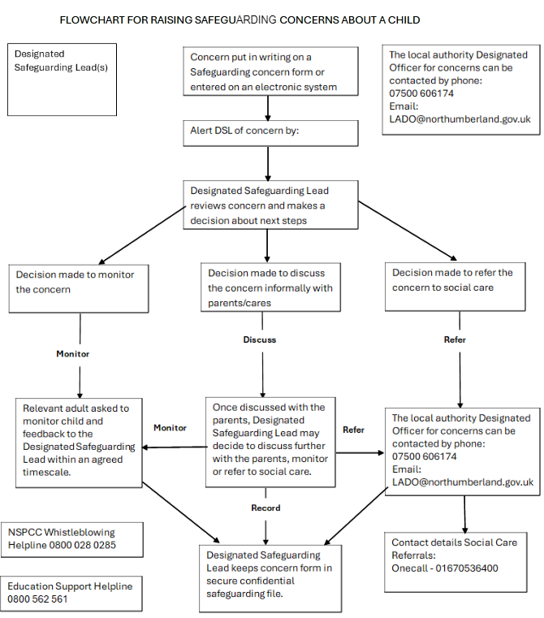

|  |
| --- |
| **Appendix H - Flowchart for sexual violence and sexual harm** |

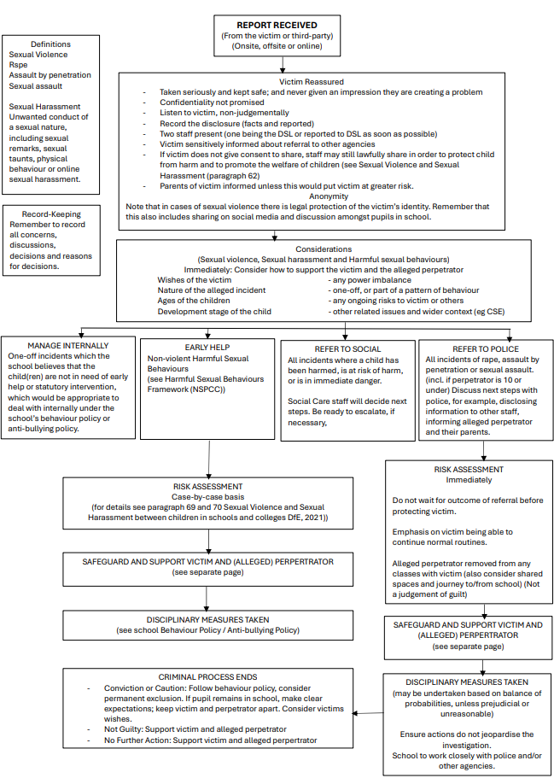

|  |
| --- |
| **Appendix I - Standards for effective Child Protection Practice in Schools** |

A school should measure its standards regarding safeguarding against the expectations of the Ofsted Framework

[Ofsted handbooks and frameworks - GOV.UK (www.gov.uk)](https://www.gov.uk/government/collections/ofsted-handbooks-and-frameworks)

and the arrangements of the Northumberland Children's and Adults Safeguarding Partnership

<https://www.proceduresonline.com/northumberlandcs/index.html>

|  |
| --- |
| **Appendix J - Dealing with allegations against people who work with children**  **Allegations or concerns about an adult working in the school whether as a teacher, supply teacher, other staff, volunteers, or contractors** |

At SEATON DELAVAL FIRST School we recognise the possibility that adults working in the school may harm children, including governors, volunteers, supply teachers and agency staff. Any concerns about the conduct of other adults in the school should be taken to the headteacher without delay; any concerns about the headteacher should go to the Chair of Governors who can be contacted by asking the office for their contact information.

Any concerns about the conduct of a member of staff, supply teachers, volunteers or contractors should be reported to the headteacher/principal.

Concerns may come from various sources, for example, a suspicion; complaint; or disclosure made by a child, parent, or other adult within or outside of the organisation; or because of vetting checks undertaken.

The headteacher/principal must decide whether the concern is an allegation or low-level concern. The term ‘low-level’ concern does not mean that it is insignificant, it means that the behaviour towards a child does not meet the threshold for referral to the Local Authority Designated Officer (LADO) (see below).

**Allegations**

It is an allegation if the person* has:

* behaved in a way that has harmed a child, or may have harmed a child and/or;
* possibly committed a criminal offence against or related to a child and/or;
* behaved towards a child or children in a way that indicates he or she may pose a risk of harm to children; and/or
* behaved or may have behaved in a way that indicates they may not be suitable to work with children (also includes behaviour outside the school).

(*Person could be anyone working in the school or a college that provides education for children under 18 years of age, including supply teachers, volunteers, and contractors.)

Allegations should be reported to the LADO 'without delay'.

Before contacting the LADO, schools and colleges should conduct basic enquiries in line with local procedures to establish the facts to help them determine whether there is any foundation to the allegation, being careful not to jeopardise any future police investigation.

LADO’s role is not to investigate the allegation, but to ensure that an appropriate investigation is carried out, whether that is by the police, children’s social care, the school or college, or a combination of these.

**Low-level Concerns**

Concerns may be graded Low-level if the concern does not meet the criteria for an allegation; and the person* has acted in a way that is inconsistent with the staff code of conduct, including inappropriate conduct outside of work. Example behaviours include, but are not limited to:

* being over friendly with children;
* having favourites;
* taking photographs of children on their mobile phone;
* engaging with a child on a one-to-one basis in a secluded area or behind a closed door; or,
* using inappropriate sexualised, intimidating, or offensive language.

If the concern has been raised via a third party, the headteacher/principal should collect as much evidence as possible by speaking:

* directly to the person who raised the concern, unless it has been raised anonymously;
* to the individual involved and any witnesses.

Reports about supply staff and contractors should be notified to their employers, so any potential patterns of inappropriate behaviour can be identified.

Staff should be encouraged and feel confident to self-refer, where, for example, they have found themselves in a situation which could be misinterpreted, might appear compromising to others, and/or on reflection they believe they have behaved in such a way that they consider falls below the expected professional standards.

Low-level concerns should be recorded in writing [Yellow Folder] and shared with OF or AB [DSL’s] asap:

* name* of individual sharing their concerns
* details of the concern
* context in which the concern arose
* action taken

(* if the individual wishes to remain anonymous then that should be respected as far as reasonably possible)

Records must be kept confidential, held securely, and comply with the Data Protection Act 2018. Schools and colleges should decide how long they retain such information, but it is recommended that it is kept at least until the individual leaves their employment.

Records should be reviewed so that potential patterns of concerning, problematic or inappropriate behaviour can be identified.

If a concerning pattern of behaviour is identified and now meets the criteria for an allegation, then the matter should be referred to the LADO.

The records' review might identify that there are wider cultural issues within the school or college that enabled the behaviour to occur. This might mean that policies or processes could be revised, or extra training delivered to minimise the risk of it happening again.

**What is a Local Authority Designated Officer or LADO?**

The role of LADO was initially set out in the HM Government guidance Working Together to Safeguard Children 2010 and continues in Working Together 2018 and 2023

The LADO works within Children’s Services and should be alerted to all cases in which it is alleged that a person who works with children has:

* behaved in a way that has harmed, or may have harmed, a child
* possibly committed a criminal offence against children, or related to a child
* behaved towards a child or children in a way that indicates s/he is unsuitable to work with children.

This role applies to paid, unpaid, volunteer, casual, agency and self-employed workers and all adults outside the school workforce. They capture concerns, allegations, or offences; this can include concerns about their own personal life, e.g., incidents of domestic violence or child protection concerns relating to their own family.

If there is an allegation against the Headteacher then concerns should be reported directly to the Chair of Governors and LADO.

The LADO is involved from the initial phase of the allegation through to the conclusion of the case. They will provide advice, guidance and help to determine whether the allegation sits within the scope of the procedures. **Schools should seek advice from the LADO as soon as an allegation is made.**

The LADO coordinates information‐sharing with the right people and will also monitor and track any investigation, with the aim to resolve it as quickly as possible – the LADO for Northumberland is **Louise Okenabirhie**

[**lado@northumberland.gov.uk**](mailto:lado@northumberland.gov.uk)

For safeguarding information for professionals, including LADO contact details, please follow this link:

[lado-information-and-flowchart.pdf (proceduresonline.com)](https://proceduresonline.com/trixcms1/media/12699/lado-information-and-flowchart.pdf)

To make a referral use this form

[LADO Agency Referral Form (office.com)](https://forms.office.com/Pages/ResponsePage.aspx?id=3qkTu5CC8EKpgNw73-cPQOqnfVRnt4BKoiapHnEu1qRURjRZQUw5RTRRUzlXVTNUTkI4OU5NUVlEMi4u)

**Call:** 07500 606174 (Monday to Thursday 08:30-17:00, Friday 08:30-16:30) or 01670 536400 (Out of hours)

|  |
| --- |
| **Appendix L - Mental Health Pathways and Signposting** |

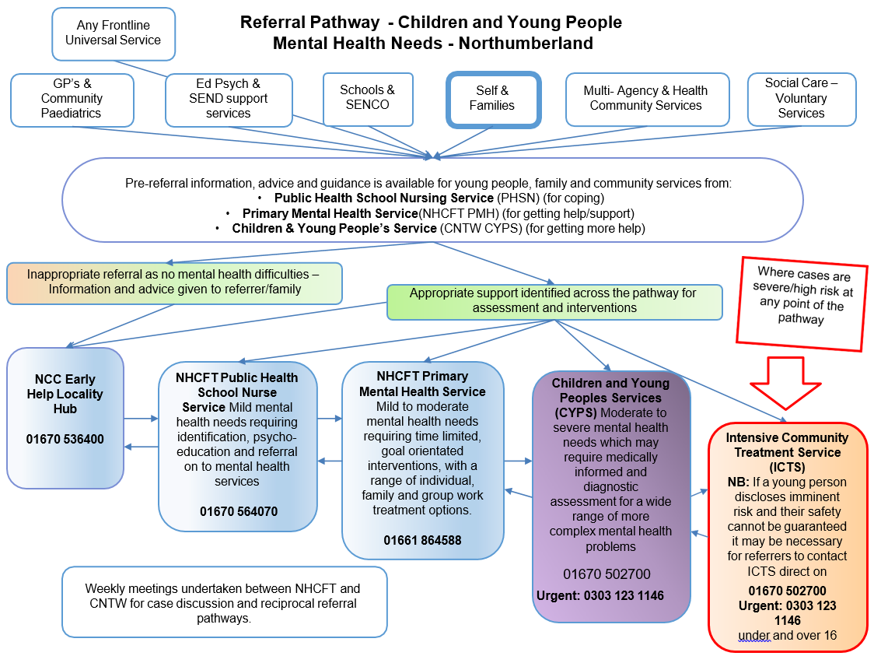

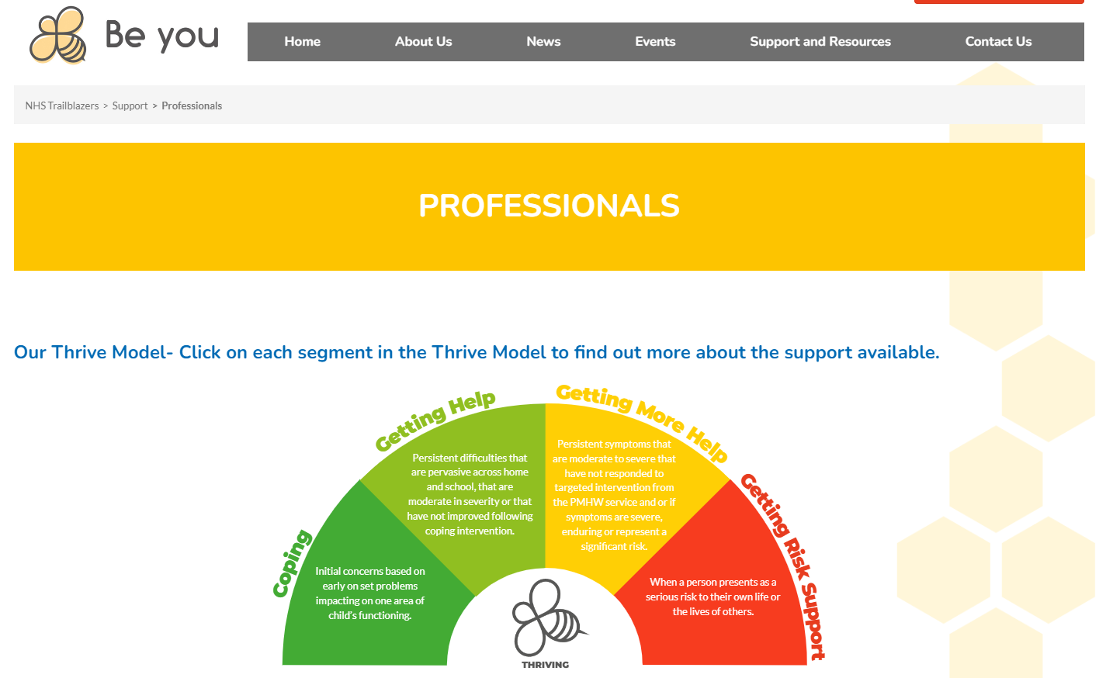

**APPENDIX M Responsibilities for school attendance**

[**https://assets.publishing.service.gov.uk/media/6274ecb2d3bf7f5e3916fb5f/Summary_table_of_responsibilities_for_school_attendance.pdf**](https://assets.publishing.service.gov.uk/media/6274ecb2d3bf7f5e3916fb5f/Summary_table_of_responsibilities_for_school_attendance.pdf)

|  |  |
| --- | --- |
| **Attendance Category** | **School Actions** |
| All pupils | * Have a clear school attendance policy on the school website which all staff, pupils and parents understand. * Develop and maintain a whole school culture that promotes the benefits of good attendance. * Accurately complete admission and attendance registers. * Have robust daily processes to follow up absence. * Have a dedicated senior leader with overall responsibility for championing and improving attendance. |
| Pupils at risk of PA | * Proactively use data to identify pupils at risk of poor attendance. * Work with each identified pupil and their parents to understand and address the reasons for absence, including any in-school barriers to attendance. * Where out of school barriers are identified, signpost and support access to any required services in the first instance. * If the issue persists, take an active part in the multi-agency effort with the local authority and other partners. Act as the lead practitioner where all partners agree that the school is the best placed lead service. Where the lead practitioner is outside of the school, continue to work with the local authority and partners. |
| Persistently Absent | Continued support as for pupils at risk of becoming persistently absent and:   * Where absence becomes persistent, put additional targeted support in place to remove any barriers. Where necessary this includes working with partners. * Where there is a lack of engagement, hold more formal conversations with parents and be clear about the potential need for legal intervention in future. * Where support is not working, being engaged with or appropriate, work with the local authority on legal intervention. * Where there are safeguarding concerns, intensify support through statutory children’s social care. * Work with other schools in the local area, such as schools previously attended and the schools of any siblings. |
| Severely Absent | Continued support as for persistently absent pupils and:   * Agree a joint approach for all severely absent pupils with the local authority. |
| Lower attendance than peers | * Proactively use data to identify cohorts with, or at risk of, low attendance and develop strategies to support them. * Work with other schools in the local area and the local authority to share effective practice where there are common barriers to attendance. |
| Pupils with medical or SEND | * Maintain the same ambition for attendance and work with pupils and parents to maximise attendance. * Ensure join up with pastoral support and where required, put in place additional support and adjustments, such as an individual healthcare plan and if applicable, ensuring the provision outlined in the pupil’s EHCP is accessed. * Consider additional support from wider services and external partners, making timely referrals. * Regularly monitor data for such groups, including at board and governing body meetings and with local authorities. |
| Pupils with a social worker | * Inform the pupil’s social worker if there are any unexplained absences and if their name is to be deleted from the register. |

|  |
| --- |
| **Appendix O - Summary of Changes for KCSiE 2025** |

* In the section about Opportunities to teach safeguarding (para 128) the DfE plan to insert references to the revised Relationships, Sex and Health Education guidance, last published in 2021 and due to be updated this summer​
* The four Cs of online risk, content, contact, conduct and commerce (para 135) have been slightly updated with the addition of content that includes misinformation, disinformation (including fake news) and conspiracy theories.
* Educate Against Hate highlighted approaches to take within schools in this important area, and the Pears Foundation reported earlier this year that the best way to tackle misinformation, disinformation and conspiracy amongst young people is through schools, but that they’ll need much support to do so​
* The September 2024 guidance to help you Plan technology for your school is now referenced in the guidance (para 142). This self-assessment service shows how your school can plan, and use digital technology to keep children safe online, prevent cyber incidents and upgrade and maintain technology in cost-effective ways with recommendations to help meet the digital and technology standards. ​
* KCSiE 2025 includes a reminder (para 144) to take the appropriate action to meet the cyber security standards and references January’s guidance on Generative AI which sets out the capabilities and features that should be in place for users in educational settings (para 143)
* There is also a reminder about the checks schools should be undertaking for alternative provision (paras 169-170 and 331), all of which are in the Alternative Provision guidance updated in February 2025. KCSiE 2025 emphasises the need for written confirmation that full safer recruitment steps have been taken on all staff and of arrangements “that might put a child at risk” such as new staff joining the alternative provision so that checks can be made there too. Schools need to know where their students are throughout school hours (i.e. the address where they are being educated). Finally, there is guidance AP placements should be reviewed at least half termly to ensure children are attending, their needs are met, and the setting is safe, with the potential that the placement is ended if any concerns are not addressed.
* Working Together to improve school attendance 2024 is statutory guidance, so “schools, trusts, governing bodies, and local authorities must have regard to it as part of their efforts to maintain confidence in safeguarding high levels of school attendance” ​
* As such, the wording around children who are absent from education has been revised from “should work with” to schools “must work with…children’s services where school absence indicates safeguarding concerns” (para 177).
* The updated KCSiE 2025 reminds us the role of the virtual school head was extended in March 2024 to promote the education of children with a social worker and children in kinship care (para 199).
* As last year, the Government’s guidance on gender questioning children is expected to be published before the final version of Keeping Children Safe in Education on 1st September 2025 (para 204), taking into account the Supreme Court judgement that ‘sex’ means biological sex. The Equality and Human Rights Commission published an interim update in April 2024 with some of the considerations this will have for schools

|  |
| --- |
| **APPENDIX P NCASP Priorities and training recommendations** |

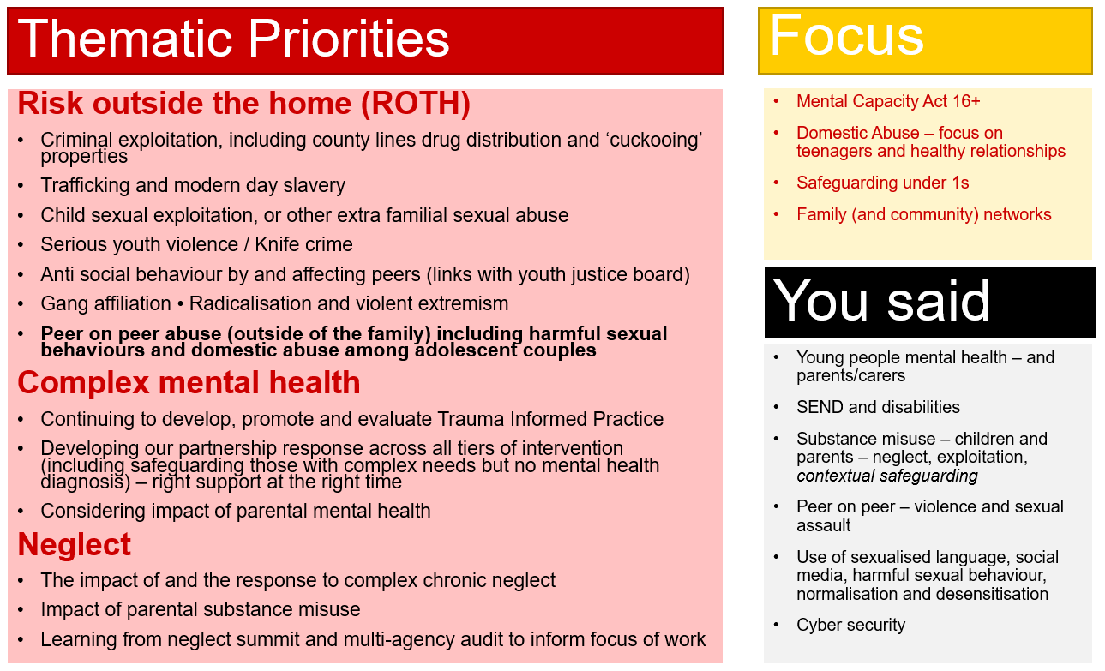

**Training Expectations**

Keeping Children Safe in Education 2025 states:

All staff should receive appropriate safeguarding and child protection training (including online safety which, amongst other things, includes an understanding of the expectations, applicable roles and responsibilities in relation to filtering and monitoring) at induction. **The training should be regularly updated.** In addition, all staff should receive safeguarding and child protection (including online safety) updates (for example, via email, e-bulletins, and staff meetings), as required, and at least annually, to continue to provide them with relevant skills and knowledge to safeguard children effectively.

The designated safeguarding lead (and any deputies) should undergo training to provide them with the knowledge and skills required to carry out the role. This training should be updated at least every two years. The designated safeguarding lead (and any deputies) should also undertake Prevent awareness training. Training should provide designated safeguarding leads with a good understanding of their own role, how to identify, understand and respond to specific needs that can increase the vulnerability of children, as well as specific harms that can put children at risk, and the processes, procedures and responsibilities of other agencies, particularly local authority children’s social care

NCASP acknowledges that some DSLs may attend training delivered by other providers, however the partnership preference is that new DSLs in Northumberland attend the one-day training delivered by the Schools' Safeguarding Team. If, however, a new DSL has attended training delivered by another provider it is expected that they attend the Making a Referral Training (this ensures they have a working knowledge on NCC/NCASP procedures).

|  |
| --- |
| **APPENDIX Q Contextual Safeguarding Links** |

In partnership with the Local Authority and partners on NCASP schools will ensure they have access to local information which support’s them address local issues using local intelligence.

Intelligence may be gained through:

* local Community Safety Leads [Northumberland County Council - Neighbourhood problems](https://www.northumberland.gov.uk/Protection/Neighbourhood.aspx#communitysafetyteam)
* communication with neighbourhood beat teams of Northumbria Police
* the Counter Terrorism Local Profile (which is in the Prevent Folder on the DSL SharePoint [Designated Safeguarding Lead Resources - OneDrive (sharepoint.com)](https://northumberland365-my.sharepoint.com/shared?id=%2Fsites%2FVirtualSchoolResources%2FDesignated%20Teacher%20for%20Looked%20After%20Children%20Resou&listurl=https%3A%2F%2Fnorthumberland365%2Esharepoint%2Ecom%2Fsites%2FVirtualSchoolResources%2FDesignated%20Teacher%20for%20Looked%20After%20Children%20Resou)
* Attendance at local VOLS (violent Offender Locality meetings)
* The Schools’ Safeguarding team, who will ensure local issues are addressed at the NCASP half termly locality briefings

School’s are also encouraged to share any local intelligence with the police using the Poilice intelligence form

[Partnership Intelligence Form - 2024.docx (sharepoint.com)](https://northumberland365.sharepoint.com/:w:/r/sites/VirtualSchoolResources/_layouts/15/Doc.aspx?sourcedoc=%7B2C916DB2-5210-4639-9FF5-8DECAD3CCDA5%7D&file=Partnership%20Intelligence%20Form%20-%202024.docx&action=default&mobileredirect=true)

|  |
| --- |
| **APPENDIX R Offensive Weapon and Knife Carrying Protocol for Education (Northumberland)** |

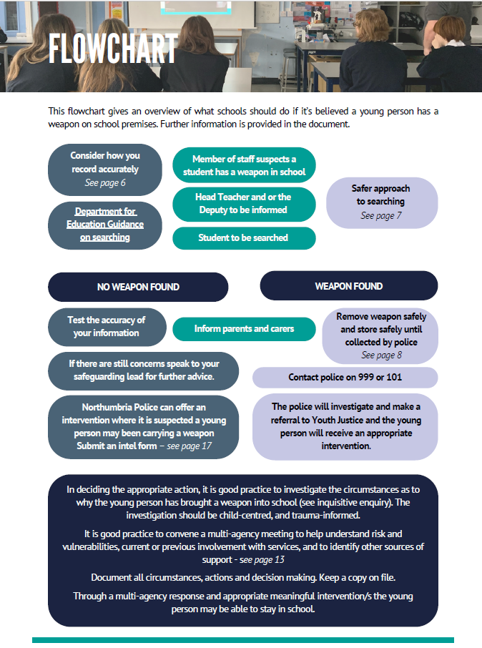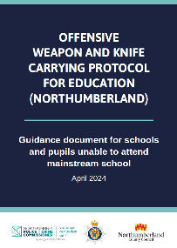

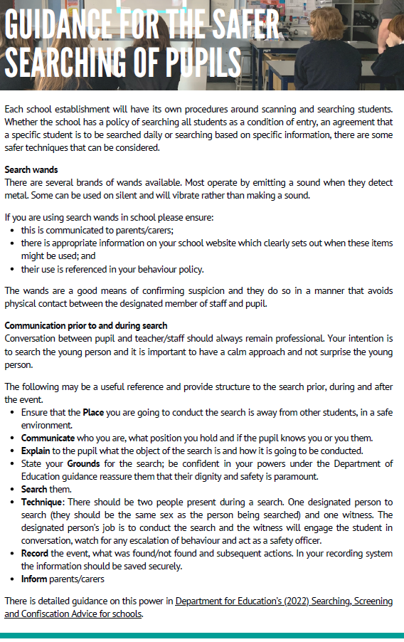

|  |
| --- |
| **APPENDIX S Northumberland Family Hubs** |

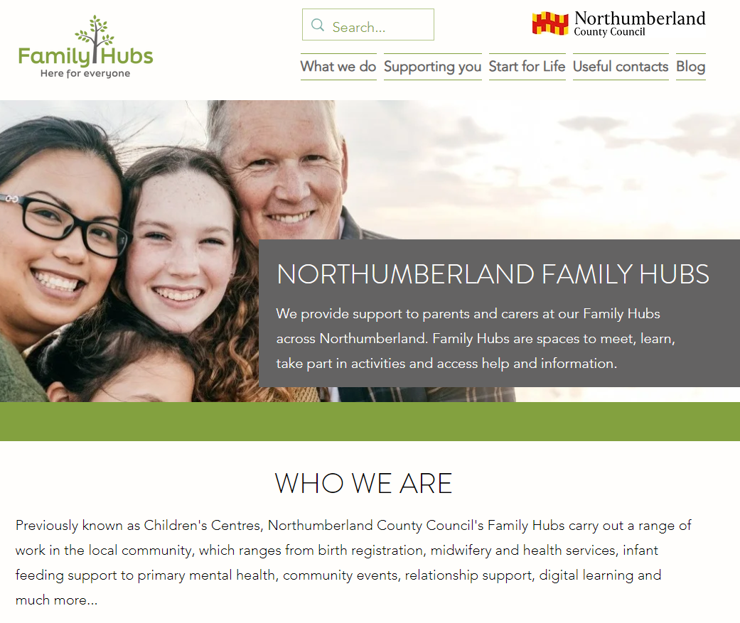

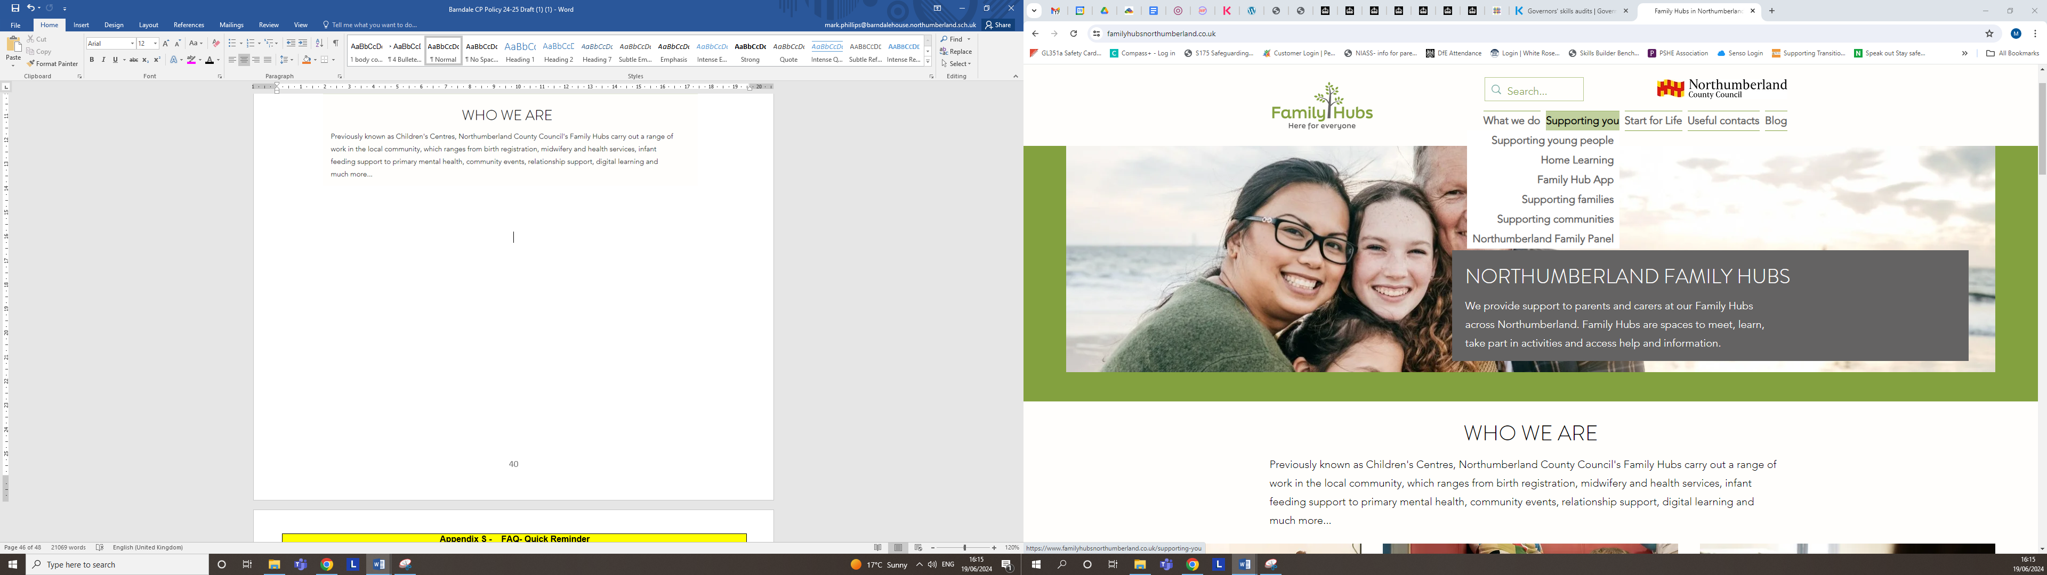

## Useful contacts and other places to find help

We've collated numerous other weblinks below that contain lots of information, tips and support for parents and carers and their families.

* [Local services and support for families](https://www.familyhubsnorthumberland.co.uk/find-a-family-hub)
* [Growing Healthy Northumberland 0-19 app](https://apps.apple.com/us/app/childrens-health-service-hdft/id1593862786)
* [Northumberland Communities Together](https://www.northumberland.gov.uk/coronavirus/Northumberland-Communities-Together/NCT.aspx)
* [Domestic abuse and getting help](https://www.familyhubsnorthumberland.co.uk/domestic-abuse)
* [Cost of Living support](https://www.northumberland.gov.uk/Support.aspx)
* [Northumberland Libraries](https://northumberland.spydus.co.uk/cgi-bin/spydus.exe/MSGTRN/WPAC/HOME)
* [Citizen's Advice](https://www.citizensadvicenorthumberland.org.uk/)

​

Local support services

If you live in Northumberland, Northumberland Frontline is a one-stop shop webpage with all available services in Northumberland. Find out more at [northumberlandfrontline.org.uk](https://northumberlandfrontline.org.uk/)

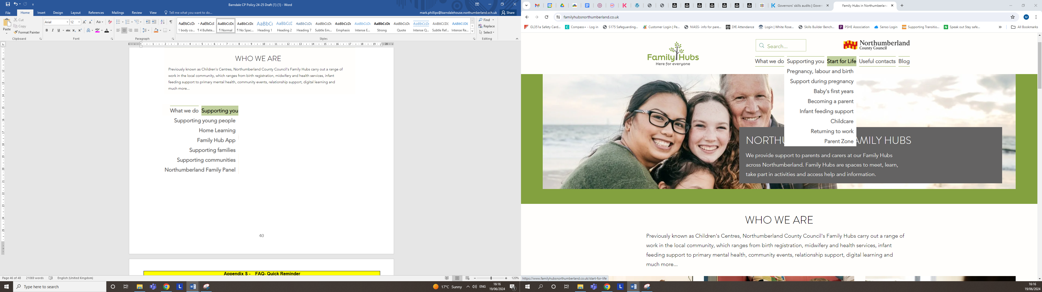

**Appendix T - FAQ- Quick Reminder**

**What do I do if I hear or see something that worries me?**

* *Report to the designated safeguarding lead or head teacher. Please remember all reports must be recorded, reporting verbally is not enough*
* *If that is not possible, telephone Children’s Services (OneCall 01670 536400) as quickly as possible. (In an emergency call 999 for the police)*

**What are my responsibilities for safeguarding and child protection?**

* ***To know the name of your designated safeguarding lead*** *and who to contact if they are not available*
* ***To respond*** *appropriately to a child and ensure the child/young person knows you are taking their concerns seriously*
* ***To report*** *to the Designated Safeguarding Lead or directly to Social Care if that is not possible*
* ***To record*** *your concerns, using your school's agreed paperwork*
* ***Do not do nothing***

**Can I go to find someone else to listen?**

* *No! You should never stop a child who is freely recalling significant events; however, you may want to have a colleague with you who is recording the child’s disclosure while you actively listen, giving them 100% of your attention*

**Can I promise to keep a secret?**

* *No! The information becomes your responsibility to share to protect. As an adult, you have a duty of care towards a child or young person*

**Can I ask the child questions?**

* *You should never ask probing questions*
* *However, you* ***can*** *ask a child to repeat a statement or for clarification*
* *Do not make judgements or say anything about the alleged abuser; it may be construed as contriving responses.*

**Do I need to write down what was said?**

* ***Yes,*** *as soon as possible, exactly what was said. Use your school’s agreed paperwork and make sure you date and sign the record*
* *Make sure you record facts and not opinions*

|  |
| --- |
| **Appendix U - Key Contacts** |

|  |  |
| --- | --- |
| **Advice Area** | **Contact** |
| For advice on making a referral or to make a referral for Children’s Social Care or Early Help | **OneCall: 01670 536400**  Please note you may call to raise/discuss your initial concerns; however they must then be submitted in writing.  **If you are submitting a referral, please use the link below**  [Forms (northumberland.gov.uk)](https://form.northumberland.gov.uk/form/auto/multi_agency_ref_form) |
| For further discussion about an open case or advice on the operation of child protection/safeguarding procedures of a specific case | If known, contact the allocated social worker or early help worker or  OneCall 01670 536400 |
| For generic advice on the operation of child protection/safeguarding procedures | Justine Clephane - 07879 874168 justine.clephane@northumberland.gov.uk  Vicky Kinneavy - 07966 325300 [victoria.kinneavy@northumberland.gov.uk](mailto:victoria.kinneavy@northumberland.gov.uk)  Julianne Gardner – 07731 1002669 julianne.gardner@northumberland.gov.uk |
| Allegations against people working with children | 07500 606174 OR 01670 536400 (out of hours)  Email address - [LADO@northumberland.gov.uk](mailto:LADO@northumberland.gov.uk)  The Northumberland LADO is Louise Okinabirhie, but please use the generic contact information to ensure you get a response |
| Queries in relation to the model CP policy for schools or related guidance | Justine Clephane - 07879 874168 |
| HR advice for schools | [SchoolsHR@northumberland.gov.uk](mailto:SchoolsHR@northumberland.gov.uk) |
| MAPPA – Risk Management re individuals who may pose a risk to children | Kath Burns, Senior Manager Children’s Services  Kath.burns@northumberland.gov.uk |
| MARAC - Multi Agency Risk Assessment Conference | Sarah Wintringham, Principal Education Welfare Officer  [sarah.wintringham@northumberland.gov.uk](mailto:sarah.wintringham@northumberland.gov.uk) OR |
| Attendance, children not in school and elective home education | Sarah Wintringham  [sarah.wintringham@northumberland.gov.uk](mailto:sarah.wintringham@northumberland.gov.uk) |
| Cared for Children | Tara Prescott, Deputy Virtual School Head Teacher  [Tara.Prescott@northumberland.gov.uk](mailto:Tara.Prescott@northumberland.gov.uk) |
| Early Help | Emma Walker, Early Help Team Manager  [Emma.Walker@northumberland.gov.uk](mailto:Emma.Walker@northumberland.gov.uk) |
| CPVA | Emma Walker, Early Help Team Manager  [Emma.Walker@northumberland.gov.uk](mailto:Emma.Walker@northumberland.gov.uk) |
| Monitoring/Quality Assurance re operation of schools safeguarding arrangements | Jane Walker 07752782649  Justine Clephane 07879 874168 |

OFSTED- How we inspect safeguarding in schools

Posted by: [Lee Owston, National Director Education](https://educationinspection.blog.gov.uk/author/lee-owston/), Posted on: 9 November 2023

In this blog, we’ll consider safeguarding through the course of an inspection. We’ll explain some of the main activities we undertake and why. You’ll find lots of references to [keeping children safe in education (KCSIE)](https://www.gov.uk/government/publications/keeping-children-safe-in-education--2) too. That’s because it sets out the Department for Education’s (DfE) expectations, as the regulator, of a school’s safeguarding responsibilities.

Keeping children safe is an important part of all our work. As an organisation, we are always reviewing our approaches to inspection to make sure it’s as positive and effective as possible.

Schools tell us that discussions about safeguarding can sometimes feel quite pressurised during inspections. Some of the concerns about getting decisions right in this space are natural. It’s important to stress that inspectors will be looking at whether schools have made the right decisions to keep children safe, not looking to catch schools out on technicalities. We want the very best for children and protecting them from harm is paramount.

Before we consider the journey of inspection, it’s important to be clear what we mean by a ‘culture of safeguarding’. We’ve updated our definition to take account of what we know matters most. We expect all schools to have an open and positive culture around safeguarding that puts pupils’ interests first.  We have provided further clarification in our handbook at paragraph 367 on what this means. Inspectors will consider the safeguarding culture that has been established in the school when making a judgement. Judgements will rarely rest on single issues. Inspectors will take into account a range of evidence so that they are able to evaluate the effectiveness of safeguarding arrangements.

**Before the inspection**

We contact schools the day before their inspection to set out the documents and information we’ll want to see when we are on site. We also have a longer conversation with the headteacher to talk about the school and plan the inspection.

In terms of safeguarding, we ask schools to start by providing some specific information before the inspection – this is outlined in paragraph 107 of the handbook:

* the single central record (SCR)
* a list of referrals made to the local authority
* any referrals made to the local authority designated officer regarding staff or other adults
* a list of all open cases with children’s services or social care and all pupils who have a multi-agency plan

We specifically ask schools to provide us with ‘brief details’ about the resolution of any referrals to the local authority. To clarify, these ‘brief details’ can just be drawn from local records – for example, what support was provided and by whom, or whether the case is ongoing, or the situation is now being monitored.

The records that schools draw from should have enough detail for the inspector to be able to understand the overall concerns that have been identified and the support and help that is in place for children. The exact level of detail required is explained further in paragraph 68 of KCSIE, but they should:

* be clear and comprehensive
* detail how concerns were followed up
* note any actions taken, the decision reached and the outcome

**During the inspection**

Discussions about safeguarding are woven throughout the inspection and will be informed by the information and records provided. We explain more in our [webinars](https://youtube.com/playlist?list=PLLq-zBnUkspNBqIkGS-MGKu8XQvP7-H2E&si=cJOkcp-k-_SEK1DQ) and the handbook, but there are a few main activities:

* reviewing the single central record
* meeting with the designated safeguarding lead (DSL)
* discussions with staff and pupils.

The single central record

When we review the SCR, we’re checking against the minimum recording requirements as set out in paragraphs 268 to 272 of KCSIE. We might also ask questions about recruitment more widely, such as:

* How are posts advertised?
* Who sits on appointment panels and what training do they have?
* How are new staff inducted?

We typically carry out the check at the start of the inspection. We do it at the start so that if there are any minor safeguarding improvements that can be rectified during the inspection, schools have the opportunity to do so. We discuss further what we mean by minor safeguarding improvements below.

All that said, we’ll want to know that this document is well managed, and that staff are suitable to be working with children. Sadly, some predatory people do try to join the staff of schools. The SCR is an important safety mechanism.

As [our chief inspector has said before](https://www.gov.uk/government/speeches/national-governance-association-speech), there is no expectation that governors and trustees go through the SCR themselves. But governors and trustees are responsible for making sure that their school fulfils its statutory duties. It’s therefore important that governors and trustees have mechanisms in place to make sure that key safeguarding and safer recruitment duties are undertaken effectively.

Meeting with the designated safeguarding lead

Inspectors will meet with the designated safeguarding lead (DSL) to explore the culture of safeguarding more fully. We’ll specifically ask the DSL whether there have been any safeguarding incidents or allegations since the last inspection. If there have been, leaders should be able to demonstrate how they have used the guidance in KCSIE to respond appropriately. This is likely to involve information-sharing with the right agencies and people (more about this below).

We’ll often sample case files and discuss referrals in this meeting. As part of these discussions, we are assuring ourselves that any concerns are dealt with in a timely way. By that, we mean without any unnecessary delay. Timings will depend on local thresholds and guidance. We’ll explore how any referrals are made, what actions are taken and how things are resolved.

We’ll also ask about staff training and how leaders make sure that staff have the relevant knowledge and skills to safeguard children effectively. Above all, all staff should be aware of the indicators of abuse and know what to do if they have concerns about a child, no matter how minor those concerns might be. These expectations are set out fully in part 1 of KCSIE.

Information-sharing is a big part of effective safeguarding. Expectations are set out fully in KCSIE and you can find a useful guide to information sharing in [Working together to safeguard children](https://www.gov.uk/government/publications/working-together-to-safeguard-children--2). We may discuss information-sharing further on inspection. Examples of the kind of questions we might ask are:

* What arrangements are in place to receive and share records at points of transfer?
* To what extent are you alert to the potential needs and vulnerabilities of the pupils that arrive at your school?
* How do you inform receiving schools of any concerns or support you have provided?

Topics of discussion with the DSL will vary from school to school depending on context. We’ll want to know that they understand their pupils’ needs and that the school acts on any concerns in a timely and effective way.

The meeting with the DSL is also an opportunity for us to be assured that this is a school that is reflective and receptive to challenge. By that, we mean that staff understand that keeping children safe is an ongoing endeavour and that there are always aspects of work that can be improved. If we spot something that perhaps does not quite look right, we’ll want to explore this and make sure the school’s systems keep children safe.

Discussions with staff and pupils

Inspectors will take lots of opportunities to talk to a range of stakeholders during different activities. We’ll prioritise talking to staff and pupils. From a staff perspective, we’ll be keen to know about their training and the actions they should take if they have a concern. We might explore the particular context and how any local issues are factored into training. For example, this might be about support for looked after children or unaccompanied asylum-seeking and refugee children.

When speaking to pupils, we’ll want to know that they feel that there are people at the school who they can talk to if they have a concern, and who will act on those concerns. We’ll do this in an age-appropriate way. And we will not automatically assume that anything worrying that might come up is representative of all pupils’ views. If pupils do raise any worries, we’ll make sure we share these with the relevant staff in school and test out views with wider groups. We’ll be very careful not to jump to any conclusions and will be mindful of confidentiality.

That commitment to evaluating things proportionately extends to any concern that staff, parents or pupils might share in surveys too – we will weigh any matters carefully and speak with more people and explore wider evidence if we need to.

**Making a judgement about safeguarding**

Inspectors will reflect carefully on all the evidence they gather to arrive at a judgement. We will judge safeguarding as effective or ineffective. In 99% of inspections that we undertook in the last academic year, we judged that safeguarding is effective.

Inspectors can also identify what we have described in the handbook as ‘minor safeguarding improvements.’ Examples might include administrative errors in paperwork or out-of-date policies.

Minor improvements, by definition, are those that do not have an immediate impact on the safety of pupils. Where it is possible to do so, we’ll want to be satisfied that the school will address them before the end of the inspection, although we understand that some things might reasonably take a little longer.

To reassure you, and as we explain in our webinars and training for inspectors, we know that schools cannot be everything to everyone. KCSIE is a vital tool for schools when it comes to safeguarding. Schools that are fulfilling their duties, by ensuring that they have systems in place to protect children from harm, will know they are doing all they can.

If we do judge safeguarding to be effective but that some minor improvements are required, that will not stop the school being judged good or outstanding.

In the rare circumstance that we judge a school to be inadequate due only to ineffective safeguarding arrangements, we will return for a monitoring inspection within 3 months from the publication of the report. This will broadly follow [our other monitoring inspections](https://www.gov.uk/government/publications/school-inspection-handbook-eif/school-monitoring-handbook-for-september-2023) but will focus on whether safeguarding is now effective. If the school has resolved the safeguarding concerns, its overall grade is likely to improve.

We understand that schools can be worried about how their safeguarding practices will be judged. However, Ofsted does not expect anything from schools beyond what is set out in KCSIE and our handbooks. If schools have an open and positive culture around safeguarding that puts pupils’ interests first, and if they are following the requirements set out in KCSIE, they (like the vast majority of schools) will be judged to have effective safeguarding.

**Find out more**

If you want to know more about our inspection of safeguarding you can find [a dedicated recorded webinar on our YouTube channel](https://www.youtube.com/watch?v=OTJYYNP9AEc). For more information about the SCR you can watch [a KCSIE series](https://kcsie.orcula.co.uk/home) from the DfE.

This blog supports our [wider series of webinars for schools](https://youtube.com/playlist?list=PLLq-zBnUkspNBqIkGS-MGKu8XQvP7-H2E&si=cJOkcp-k-_SEK1DQ). School leaders, staff and governors have asked to hear from us directly. Our webinars and blogs aim to do exactly that.