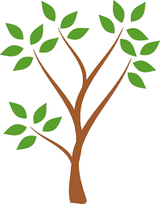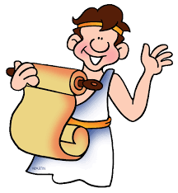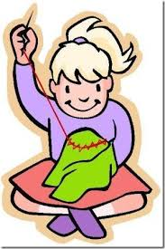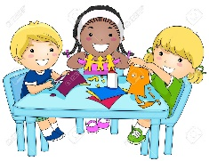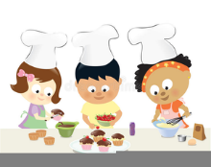

**DT Year 3 &4**

Textiles

Can they join textiles of different types in different ways? Can they choose textiles both for their appearance and also qualities?

Do they think what the user would want when choosing textiles?

Have they thought about how to make their product strong?

Can they devise a template?

Can they explain how to join things in a different way?

**Art Year 3 &4**Can they add onto their work to create texture and shape?

Can they work with life size materials?

Can they create pop-ups? • Can they use more than one type of stitch?

Can they join fabric together to form a quilt using padding?

Can they use sewing to add detail to a piece of work?

Can they add texture to a piece of work?

Artist: Roy Lichtenstein

**PSHE**

**Year 3 -What are families like? What makes a community?**

Year 4- How do we mange feelings?

**Science Year 3**

**Plants**

Can they identify and describe the functions of different parts of flowering plants? (roots, stem/trunk, leaves and flowers)?

Can they explore the requirement of plants for life and growth (air, light, water, nutrients from soil, and room to grow)?

Can they explain how they vary from plant to plant?

Can they investigate the way in which water is transported within plants?

Can they explore the part that flowers play in the life cycle of flowering plants, including pollination, seed formation and seed dispersal?

**Animals including humans**

Can they explain the importance of a nutritionally balanced diet?

Can they describe how nutrients, water and oxygen are transported within animals and humans?

Can they identify that animals, including humans, cannot make their own food: they get nutrition from what they eat?

Can they describe and explain the skeletal system of a human?

Can they describe and explain the muscular system of a human?

Can they explain how the muscular and skeletal systems work together to create movement?

**Year 4Animals including humans** Can they identify and name the basic parts of the digestive system in humans?

Can they describe the simple functions of the basic parts of the digestive system in humans?

Can they identify the simple function of different types of teeth in humans?

Can they compare the teeth of herbivores and carnivores?

Can they explain what a simple food chain shows?

Can they construct and interpret a variety of food chains, identifying producers, predators and prey?

Can they classify living things and non-living things by a number of characteristics that they have thought of?

**States of matter**

Can they compare and group materials together, according to whether they are solids, liquids or gases?

Can they explain what happens to materials when they are heated or cooled?

Can they measure or research the temperature at which different materials change state in degrees Celsius?

Can they identify the part that evaporation and condensation have in the water cycle?

**Computing**

**Year 3**

Programming- **Events and actions**

Year 4

Programming- **Repetition-Logo**

**RE**

**Year 3**

How do festivals and worship show what matter to Muslims?

How do festivals and family life show what matters to Jewish people?

Year 4

**RE**

**What does it mean to be Hindu in Britain today?**

**Why do Christians call the day Jesus died ‘Good Friday’?**

**History Year 3**

Knowledge and interpretation

Do they appreciate that the early Brits would not have communicated as we do or have eaten as we do?

Can they begin to picture what life would have been like for the early settlers?

Can they recognise that Britain has been invaded by several different groups over time?

Do they realise that invaders in the past would have fought fiercely, using hand to hand combat?

Can they suggest why certain events happened as they did in history?

Can they suggest why certain people acted as they did in history?

**Year 4**

Knowledge and interpretation

Can they explain how events from the past have helped shape our lives?

Do they appreciate that wars have happened from a very long time ago and are often associated with invasion, conquering or religious differences?

Do they know that people who lived in the past cooked and travelled differently and used different weapons from ours?

Do they recognise that the lives of wealthy people were very different from those of poor people?

Do they appreciate how items found belonging to the past are helping us to build up an accurate picture of how people lived in the past?

**Cross Curricular Links**

**English**

Playscripts, instructions, story writing.

**Maths**

Weigh& measuring linked to cooking.

Co- ordinates linked to map work.

Angles linked to computing.

Money

**PE Year 3**

**Dance**

Can they improvise freely, translating ideas from a stimulus into movement?

Can they share and create phrases with a partner and in small groups?

Can they repeat, remember and perform these phrases in a dance?

Games

Do they know and use rules fairly to keep games going?

Can they keep possession with some success when using equipment that is not used for throwing and catching skills?

**Year 4 Dance**

Can they take the lead when working with a partner or group?

Can they use dance to communicate an idea?

Can they work on their movements and refine them?

Is their dance clear and fluent?

Games

Can they keep possession of the ball?

Can they move to find a space when they are not in possession during a game?

Can they vary tactics and adapt skills according to what is happening?

**Geography Year 3**

Physical Geography

Can they use maps and atlases appropriately by using contents and indexes?

Can they describe how volcanoes are created?

Can they describe how earthquakes are created?

Can they confidently describe physical features in a locality?

Can they locate the Mediterranean and explain why it is a popular holiday destination?

Can they recognise the 8 points of the compass (N,NW, W, S, SW, SE, E, NE)?

Exceeding

Can they explain why a locality has certain physical features?

**Year 4**

Can they describe the main features of a well-known city?

Can they describe the main features of a village?

Can they describe the main physical differences between cities and villages?

Can they use appropriate symbols to represent different physical features on a map?

**Music Year 3**Composing [including notation]

Can they use different elements in their composition?

Can they create repeated patterns with different instruments?

Can they compose melodies and songs?

Can they create accompaniments for tunes?

Can they combine different sounds to create a specific mood or feeling?

**Year 4** Composing [including notation]

Can they use notations to record and interpret sequences of pitches?

Can they use standard notation?

Can they use notations to record compositions in a small group or on their own?

Can they use their notation in a performance?

**French Year 3 Speaking** Can they have a short conversation where they are saying 2-3 things? Can they use short phrases to give a personal response? **Year 4Reading and responding**: Can they read and understand short texts using familiar language? Can they identify and note the main points and give a personal response?

Can they read independently?

Can they use a bilingual dictionary or glossary to look up new words?

**Year 3/ 4 Topic web**

**The Romans**

**Spring Term**