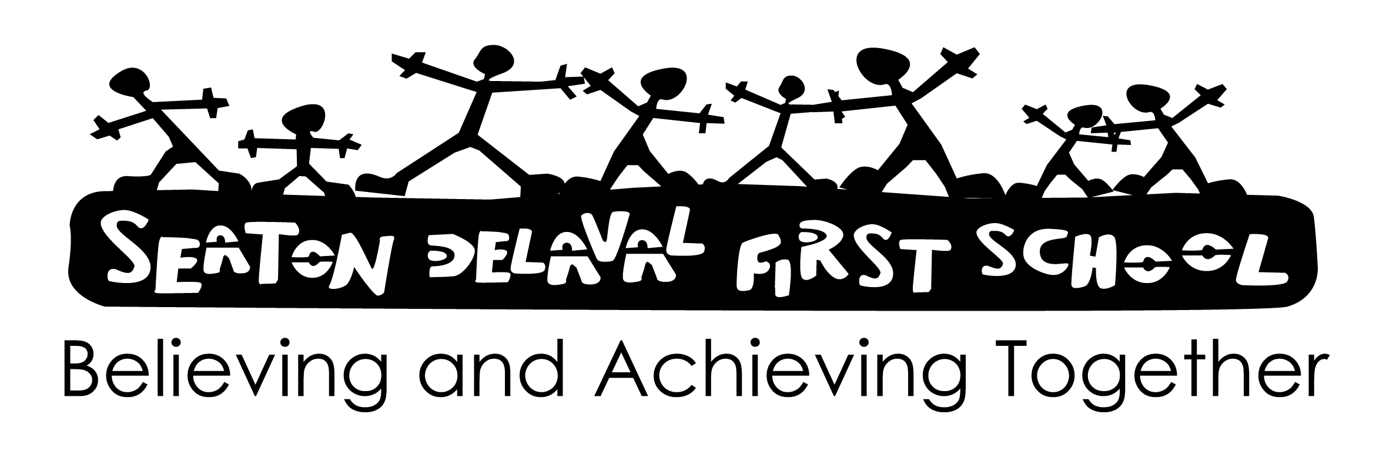

**SPORTS PREMIUM FUNDING INFORMATION**

**Funding received 2025 - 2026:** £17,240

**Planned SSP programme 2025 - 2026**

* Contribution to eligible School games costs
* Showing potential Y4 multiskills academy
* Curriculum support
* Extra-curricular clubs x 3
* Playground leaders
* Transport to sports events
* Hoopstarz day
* Golf coaching
* Cricket coaching
* Archery
* Multisports
* Relax days
* Skipping day
* Festivals of sport
* Quadkids athletics competition
* Teaching and curriculum support [3 afternoons]
* Resources
* LSA overtime to support SEND pupils to access

**Impact**

For impact see Sports Premium Impact report 2024 - 2025 (updated termly)

# Sustainability

The activities of Seaton Valley Sports Partnership are focused on using the PE and Sport Premium wherever possible to create sustainable improvements in PE and School Sport across Seaton Valley:

* Upskilling Staff - opportunities to develop staff skills, knowledge and confidence
* Community Links - creating meaningful links between the schools and community clubs, where coaches deliver in schools, or children are taken to the club for School Games competitions
* Health & Well-Being - the development of Sports Leaders, skipping and hula-hooping have increased physical activity in school playgrounds. Schools have the resources necessary, with teachers able to deliver these programmes, creating sustainability for the future
* Partnership working - 8 schools work together, networking and sharing to help the Seaton Valley Sports Partnership programme. Working with Astley High School, creating a sustainable network of support for the schools.

Some of the activities programmes and support we are able to provide with the Sport Premium would not be sustainable without further funding or passing on the costs to the pupils.