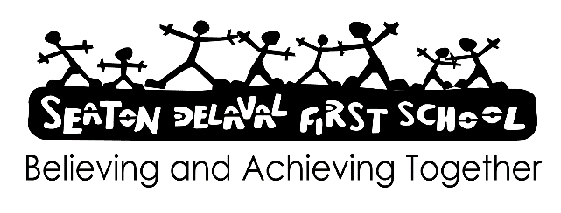

AI chatbots - parent/ carer factsheet January 2026

What are AI chatbots?
Artificial intelligence (AI) chatbots are computer programs that aim to act like humans. They answer questions and engage in conversation. Chatbots have many uses – you might have used one before without realising, e.g. websites often use them to help answer customer questions.
Chatbots usually work through typed messages, but some can also create images or use voice and video.
Around two-thirds of children aged 9 to 17 are using chatbots. The most popular ones are:
General-purpose chatbots – perform a variety of tasks like helping with homework, e.g. ChatGPT and Google Gemini
Companion-style chatbots – designed to act like friends or even romantic partners, e.g. Replika and character.ai
Chatbots integrated within social media – e.g. Snapchat’s ‘My AI’
When AI chatbots are used safely and with the right measures in place, they can be helpful for children, e.g. for education or entertainment. However, it’s important to be aware of the risks associated with AI chatbots.

Why do AI chatbots present safeguarding risks?
Using an AI chatbot can be a sign of a wider problem, like your child feeling lonely or not having someone they trust to talk to. It can also affect other safeguarding issues:
Emotional dependency – chatbots are easy to access and available 24/7. Children can form strong attachments and rely too much on them for support and friendship. Children may spend less time with real friends and family, and struggle to seek help from trusted adults
Reinforcing harmful ideas – chatbots are designed to be friendly and avoid disagreement, so they can validate dangerous thoughts and behaviours on topics like suicide and eating disorders
Promoting stereotypes – because chatbots get their information from all over the internet, their responses can repeat harmful stereotypes about race, gender and other characteristics. They might even support extremist views without challenging them
Inappropriate content – chatbots can engage in sexual conversations with children and some can even create explicit images, including child abuse material
Limiting development – the long-term effects of children using AI chatbots are not yet known, but there is some evidence that it can harm children’s thinking skills and their social and emotional development
Privacy and data issues – children might share personal and sensitive information without realising it could be stored or misused. Not all chatbot providers are clear about what data they collect or how they use it.

What can we do at home?
We talk about the risks of using AI chatbots in school, but this is always more effective if the conversations happen at home too.
Here’s how you can help keep your child safe:
Discuss chatbots together – talk about how your child might use them and the potential risks. Remind your child that chatting with AI is not the same as interacting with another person. If your child wants to use a particular chatbot, try it together so you can see how it works, spot any concerns and decide if your child can use it safely
Set rules and limits – where your child uses AI chatbots, put in place clear rules and expectations around how they use them. This can include time limits and when and where they use chatbots, such as only in shared spaces around the house
Encourage your child to question what they read – remind them that the information chatbots provide will not always be accurate or sensible. Show them how they can check facts from trusted sources, and let them know they can ask you for advice
Keep an eye on your child’s online activity – monitor or supervise their activity and be prepared to step in if you’re worried. You can set parental controls for some apps, but not all apps have this option
Check age ratings – the age ratings in app stores can help you decide whether a chatbot is suitable for your child, but they’re not always consistent or accurate. Use parental controls on your child's device to block access to inappropriate apps like Replika and character.ai
Listen to them – if your child tells you anything that’s worrying them, reassure them that you’re there to help and won’t be angry or disappointed
Talk about privacy – tell your child why it’s important that they don’t share sensitive and personal information with chatbots, such as their age, school name or location
Look out for warning signs – these might show there’s a problem. Be alert to any changes in your child’s mood or behaviour, such as:
Spending more time online unsupervised
Becoming more withdrawn and distant from real-life relationships
Complaining about being tired because they were online all night
Changes in mood after spending time on their phone or other device
Being secretive about their online activity and refusing to talk about chatbots

