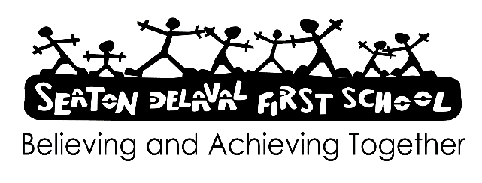

AI chatbots: staff factsheet January 2026

What are AI chatbots?
Artificial intelligence (AI) chatbots are computer programs that aim to mimic human interaction by responding to questions and simulating conversation. AI chatbots have many uses and are already common in everyday life, e.g. businesses often use them for online customer support.
Chatbot interactions and responses are typically by text but can also involve generating images and voice or video functions.
Around two-thirds of children aged 9 to 17 are using AI chatbots. The most popular AI chatbots include:
General-purpose chatbots – perform a variety of tasks, such as helping with homework, e.g. ChatGPT and Google Gemini
Companion-style chatbots – designed to act like friends or even romantic partners, e.g. Replika and character.ai
Chatbots integrated within social media – e.g. Snapchat’s ‘My AI’
When AI chatbots are used safely and with robust, effective safeguards in place, they can be helpful tools for children, e.g. for education or entertainment. However, it’s important to be aware of the risks associated with AI chatbots.

Why do AI chatbots present safeguarding risks?
A child using an AI chatbot can be a sign of a wider problem, such as loneliness or not having a trusted adult to speak to. It can also impact other safeguarding issues:
Emotional dependency – chatbots are easy to access and available 24/7, which means that children can form intense attachments and become overly reliant on them for support and friendship. They may withdraw from real-life relationships and struggle to seek help from trusted adults. Vulnerable children are especially likely to engage with companion-style chatbots
Reinforcing harmful ideas – chatbots are designed to be friendly and avoid disagreement, which means they can validate dangerous thoughts and behaviours on topics like suicide and eating disorders
Promoting stereotypes – because chatbots source their information from all over the internet, their responses can reproduce existing prejudices, such as gender, racial and ableist stereotypes. This means extremist views can go unchallenged and potentially influence children’s views and attitudes
Explicit content – chatbots can engage in sexual conversations with children and some can even generate explicit images, including child abuse material. Children can also be exposed to misogynistic content
Privacy and data issues – pupils can unknowingly share personal and sensitive information, which could be stored or misused. Not all chatbot providers are transparent about what data they collect or how they use it
Limiting development – long-term effects of children using AI chatbots are not yet known, but there is some evidence that it can negatively affect cognitive and critical-thinking abilities, and harm social and emotional development

Signs to look out for
If a pupil is facing a safeguarding issue involving AI chatbots, they might:
Spend more time online unsupervised. This might be reported by their parents/carers
Become more withdrawn and distant from real-life relationships, e.g. not engaging with peers and staff as they normally would
Complain about being tired because they were online all night
Have stronger emotional responses or outbursts when they are online
Be secretive about their use of the internet or a device – they may refuse to hand in their phone if you have a ‘no phones’ policy, or refuse to tell you what they get up to online

What you can do
To minimise the risks of misuse of AI chatbots, make sure you:
Familiarise yourself with our school’s policy on the use of AI and teaching online safety. As individuals we may have different opinions on AI, but it’s important that pupils receive consistent advice on how to keep themselves safe online and manage risks
Educate pupils on the risks of AI chatbots, that they should question any advice they receive from an AI chatbot, and how they can access support services such as Childline. If a pupil feels upset or worried, encourage them to speak to a trusted adult
Report any issues with our filtering and monitoring systems to OF or AB – some AI chatbots might avoid detection and can generate inappropriate content that should otherwise be filtered
Build trusted relationships with pupils so that they feel comfortable talking to you and can disclose any issues they may be facing
Where you have any concerns about a pupil, report these as soon as possible to our designated safeguarding leads OF or AB.

