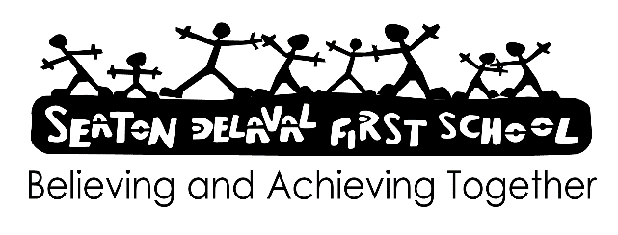

AI risks: staff factsheet January 2026

What is AI?
Artificial intelligence (AI) is the use of computer systems to solve problems and make decisions. It’s already a part of everyday life – you’ve probably come across it in the form of personalised suggestions on social media, shopping sites or route-planning apps.
Generative AI takes a written prompt and runs it through an algorithm to generate new, ‘natural’-seeming content. Tools include:
Chatbots such as ChatGPT, Google Gemini and Grammarly, which generate text
Text-to-image programs like DALL-E and Midjourney, which create images
Text-to-video programs, which create videos
AI technology is developing rapidly, and these tools will only become more sophisticated over time. For example, they’ll be able to create more convincing images or videos.
Some AI tools are not caught by filtering and monitoring systems, and can be used to generate inappropriate content that should otherwise be filtered.

How does AI pose a safeguarding risk?
Rather than being its own safeguarding issue, AI can impact other safeguarding issues:
Hacking and scams – text-generation tools can write convincing emails and text messages to trick pupils into giving malicious actors access to their accounts
AI-generated child sexual abuse images – some text-to-image tools or image-altering apps (often called ‘nudifying’ apps) could be used to create child sexual exploitation material for sexual gratification or as a means of bullying another pupil
‘Deepfake’ pornography – superimposing a person’s face into pornographic videos for sexual gratification or to humiliate the person being put in the images. AI technology is used to alter the person’s facial expressions to make the video look more convincing
‘Catfishing’ and ‘sextortion’ – criminals can use AI-generated profile pictures to appear younger than they are to befriend and groom children and young people, and then solicit information and/or images from them (e.g. nude or semi-nude photos). They can then use this to extort children into giving them money
Fake news and misinformation – text-to-image tools can be used to create convincing fake photos of world events, which could be used to promote certain beliefs (including hateful ones)
AI chatbot relationships – some AI tools allow children to chat and build a relationship with a fake person. These relationships can become very intense, and the AI may make dangerous or inappropriate suggestions

Signs to look out for
If a pupil is facing a safeguarding issue online, they might:
Spend more time online, or more time offline. This might be reported by their parents/carers
Complain of being tired because they were online all night, or have their phone going off a lot
Have stronger emotional responses or outbursts when they are online – the pupil may get unusually angry, upset or distant after checking their phone or using their computer/tablet
Be secretive about their use of the internet or a device – they may refuse to hand their phone in if ‘no phones’ is school policy, or refuse to tell you what they get up to online
Show more general signs of sexual abuse
If a child tells you that they use their device unsupervised – for example, they play on their iPad when they go to bed – this could be a red flag.

