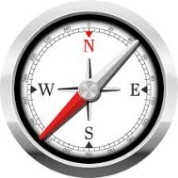

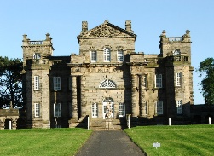
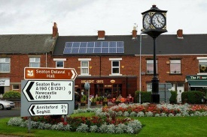


Art
Local art focus
Sketch books
Can they use their sketch books to express feelings about a subject and to describe likes and dislikes?
Can they make notes in their sketch books about techniques used by artists?
Can they suggest improvements to their work by keeping notes in their sketch books?
DT
Textiles
Can they join textiles of different types in different ways?
Can they choose textiles both for their appearance and also qualities?
(Linked to Christmas decoration)
Artist focus: Cath Kidston
Music
Year3 Charanga unit one ‘Let your spirit fly’
Performing
Do they sing in tune with expression?
Do they control their voice when singing?
Can they play clear notes on instruments?
French
Y3 Getting to know you
Say hello and goodbye
Ask what’s your name and how old are you?

PSHE
What are the rules that keep us safe? What can we do about bullying?

RE
L2.1 What do Christians learn from the Creation story? L2.2 What is it like for someone to follow God?

Geography
Geographical enquiry
Do they use correct geographical words to describe a place and the events that happen there?
Can they identify key features of a locality by using a map?
Can they begin to use 4 figure grid references?
Can they accurately plot NSEW on a map?
Can they use some basic OS map symbols?
Can they make accurate measurement of distances within 100Km?
Can they work out how long it would take to get to a given destination taking account of the mode of transport?

History
Historical enquiry
Do they recognise the part that archaeologists have had in helping us understand more about what happened in the past? (linked to rocks year 3 )
Can they use various sources of evidence to answer questions?
Can they use various sources to piece together information about a period in history?
Can they research a specific event from the past?
Can they use their ‘information finding’ skills in writing to help them write about historical information?
Can they, through research, identify similarities and differences between given periods in history?

Rocks
Can they compare and group together different rocks on the basis of their appearance and simple physical properties?
Can they describe and explain how different rocks can be useful to us?
Can they describe and explain the differences between sedimentary and igneous rocks, considering the way they are formed?
Can they begin to relate the properties of rocks with their uses?

Light
Can they recognise that they need light in order to see things?
Can they recognise that dark is the absence of light?
Can they notice that light is reflected from surfaces?
Can they recognise that light from the sun can be dangerous and that there are ways to protect their eyes?

Computing
Using the Internet
Can they find relevant information by browsing a menu?
Can they search for an image, then copy and paste it into a document?
Can they use ‘Save picture as‘ to save an image to the computer?
Can they copy and paste text into a document?
Do they begin to use note making skills to decide what text to copy?
Presentation
Can they create a presentation that moves from slide to slide and is aimed at a specific audience?
Can they combine text, images and sounds and show awareness of audience?
Do they know how to manipulate text, underline text, centre text, change font and size and save text to a folder?
Skills
Do they follow the school’s safer internet rules?
Do they recognise the difference between the work of others which has been copied (plagiarism) and re-structuring and re-presenting materials in ways which are unique and new?

Cross Curricular Links
English- historical research about Seaton Delaval Hall
Maths- data collection- geographical surveys.
Careers links – jobs in the local area, jobs linked to history and research.

PE Year 3
Balance and Coordination.
Bat and ball skills.
Acquiring and developing skills
Can they select and use the most appropriate skills, actions or ideas?
Can they move and use actions with co-ordination and control?
Games
Can they throw and catch with control when under limited pressure?
Are they aware of space and use it to support team-mates and cause problems for the opposition?
Do they know and use rules fairly to keep games going?

Year 3 Topic Web
Yellow Class- Year 3
Celebrating our Area

